**Task 1 – Active Directory Design** (6%)

• Design and draw the network **topology** based on the above scenario in your **Assignment_Your Name_YourID.docx**. Clearly label the server computer **names**, assigned **IP** addresses, assigned **domains**, and **DNS** IP addresses.

Important: When you start the lab, PLABDC01 must be powered on first. Please

note that some network services require Active Directory in order to function.

• PLABDC01 (Windows Server 2016 - Domain Controller)

• PLABDM01 (Windows Server 2016 - Domain Member Server)

• PLABDCORE01 (Windows Server 2016 - Domain Member Server Core)

• PLABSA01 (Windows Server 2016 - Domain Member Server)

• PLABWIN10 (Windows 10 Enterprise - Domain Workstation)

Lab Diagram

• Use commands **dates;ipconfig /all** to record the existing configurations, and take screenshots for each machine.

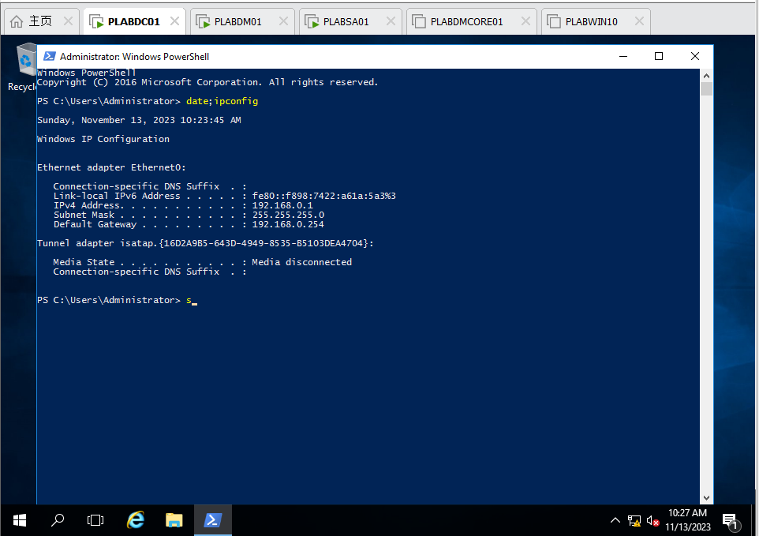

Figure 1 PLABDC01: Command date; ipconfig in PowerShell

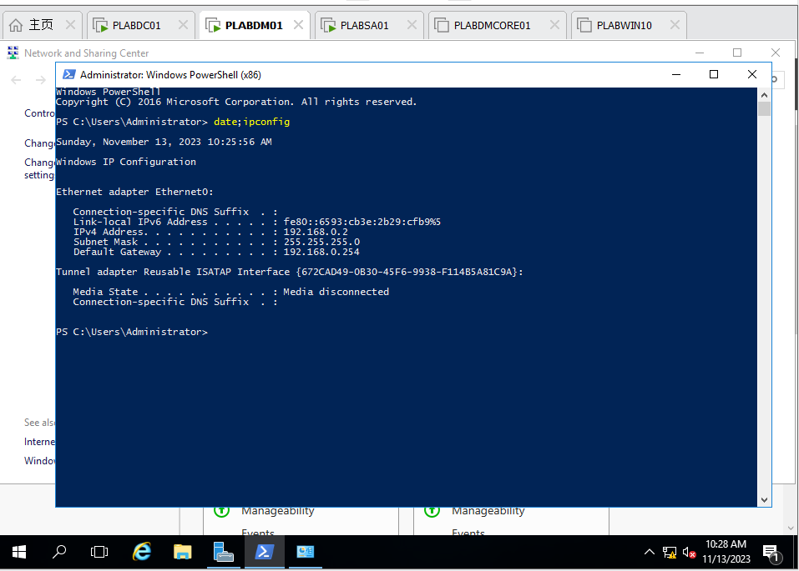

Figure 2 PLABDM01: Command date; ipconfig in PowerShell

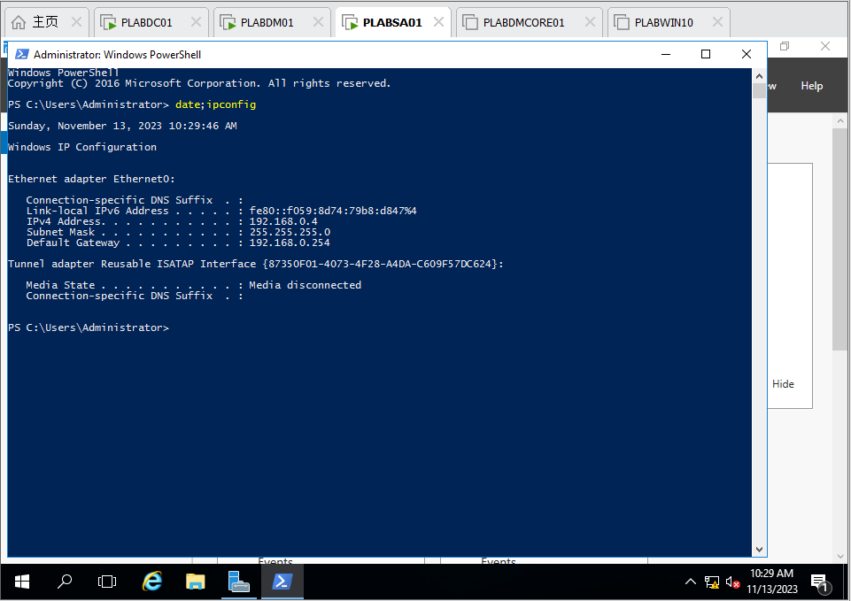

Figure 3 PLABSA01: Command date; ipconfig in powershell

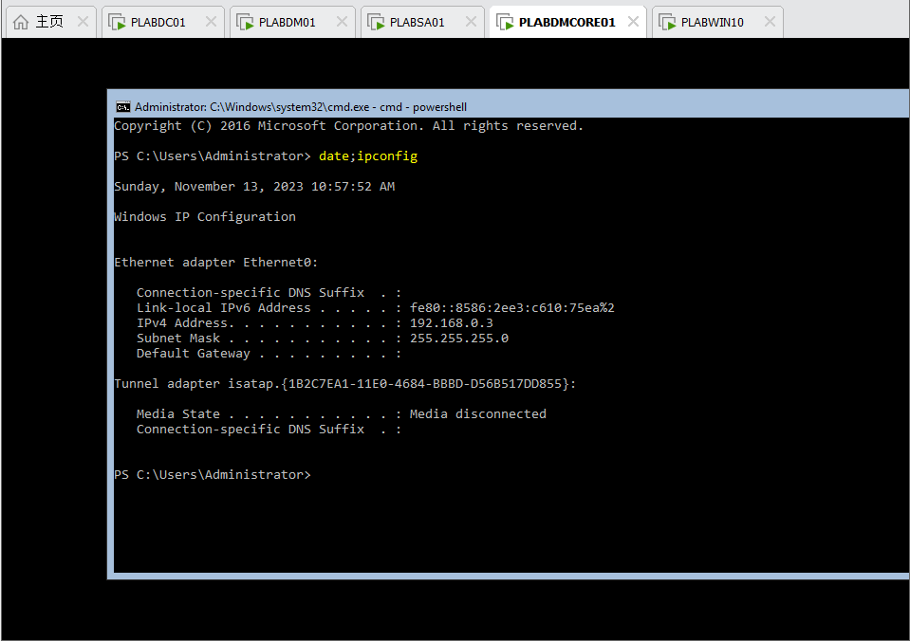

Figure 4 PLABDMCORE01: Command date; ipconfig in powershell

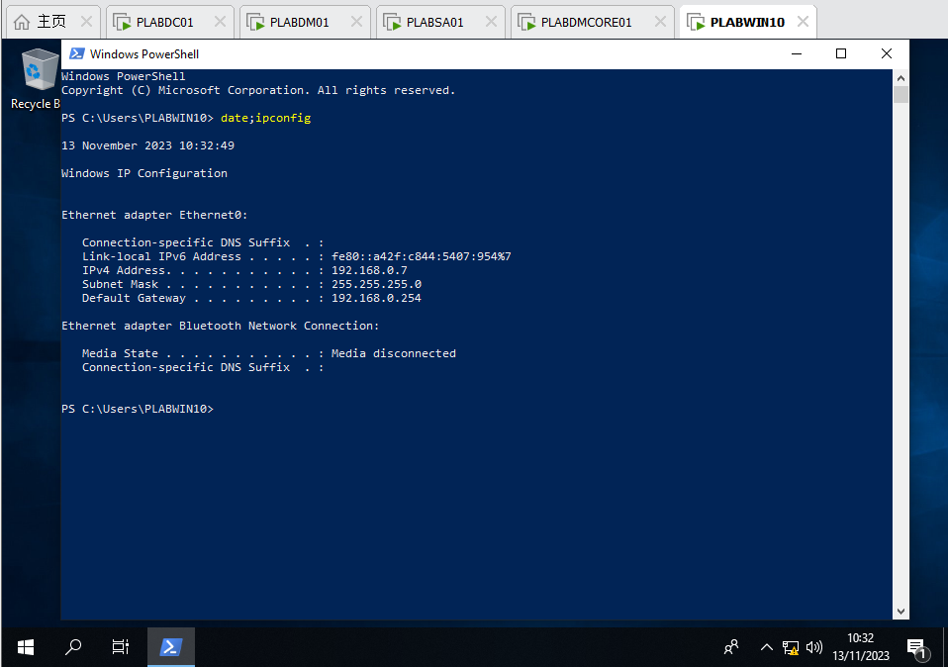

Figure 5 PLABWIN10: Command date; ipconfig in powershell

**Task 2 – Active Directory Installation** (9%)

• Configure the active directory according to the above design.

• Capture necessary screenshots to demonstrate the steps taken to configure the network, and provide some explanation for your steps.

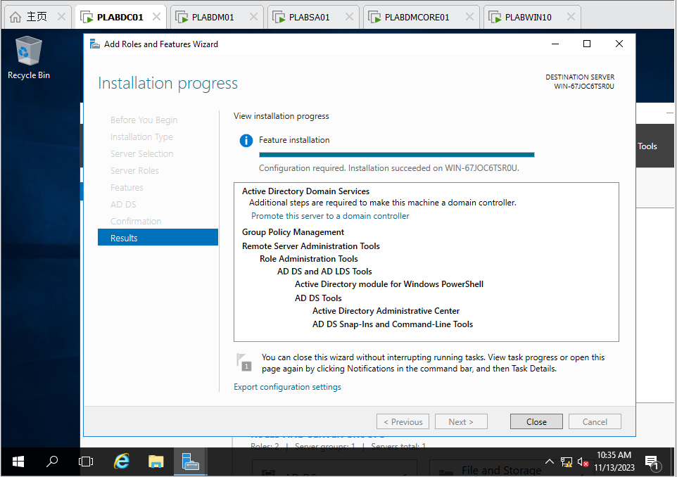

Figure 6 PLABDC01: Install ADDS (Results)

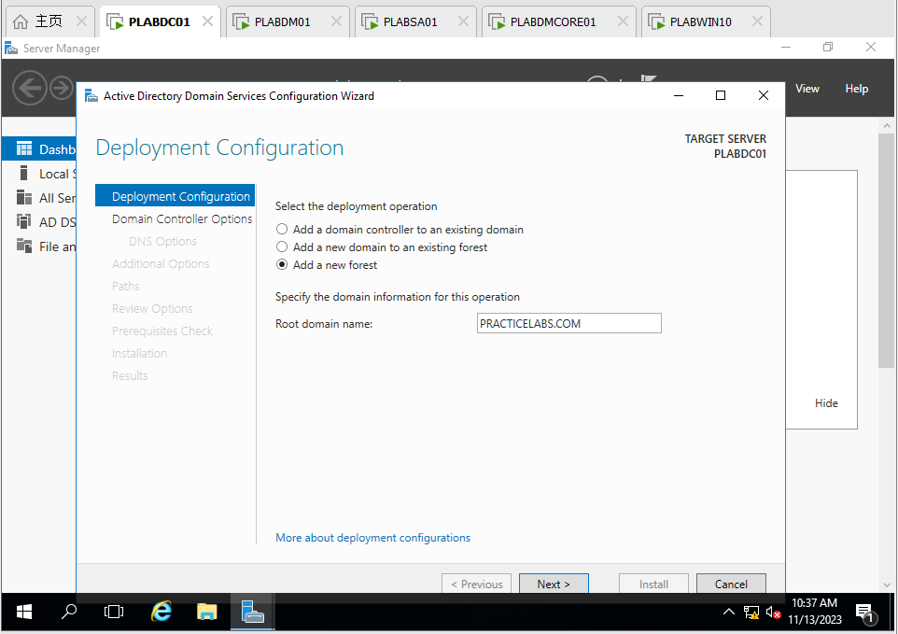

Figure 7 PLABDC01: Configure deployment operation and Root domain name

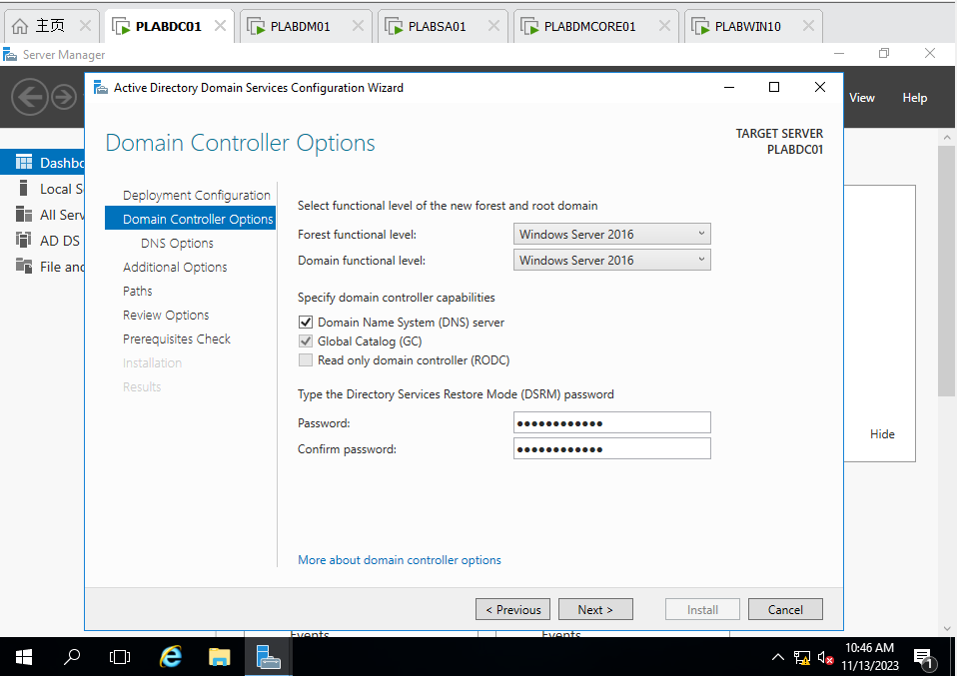

Figure 8 PLABDC01: Configure Password of DSRM

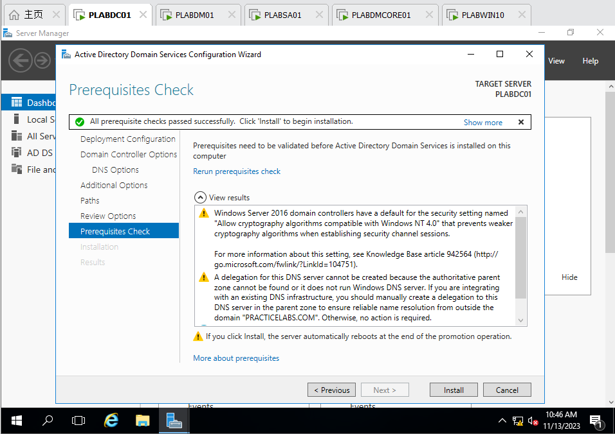

Figure 9 PLABDC01: Prerequisites Check of ADDS Service

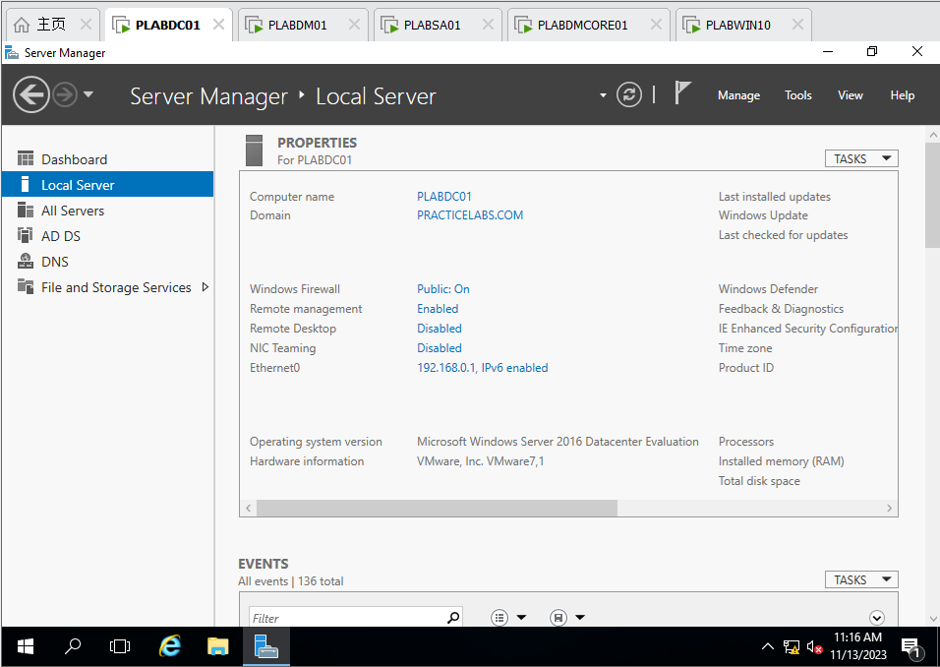

Figure 10 PLABDC01: Check the domain is done

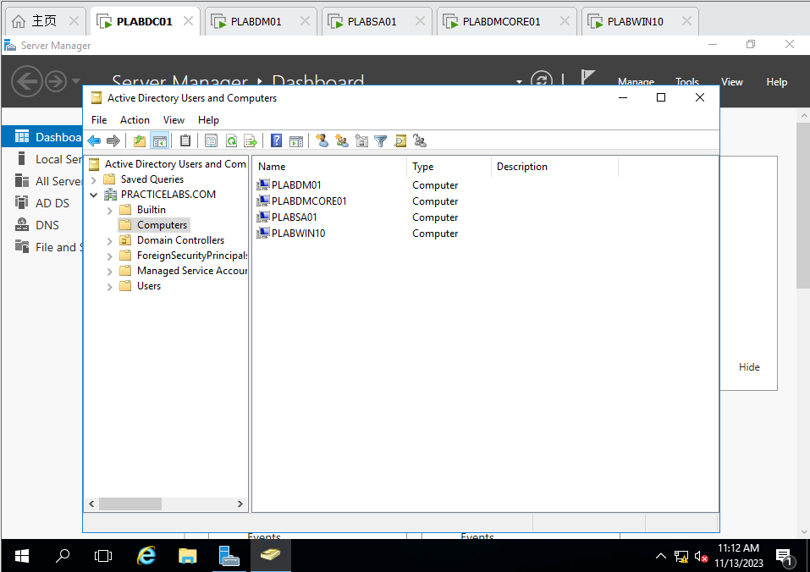

Figure 11 PLABDC01: Join *plabdm01, plabdmcore01, plabsa01, plabwin10* to the Domain

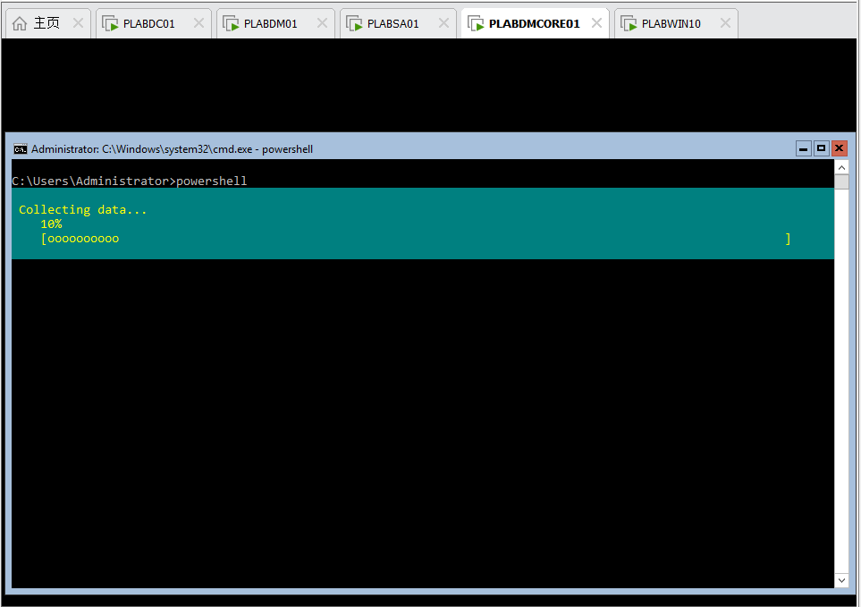

Figure 12 PLABDMCORE01: The progress of installing ADDS

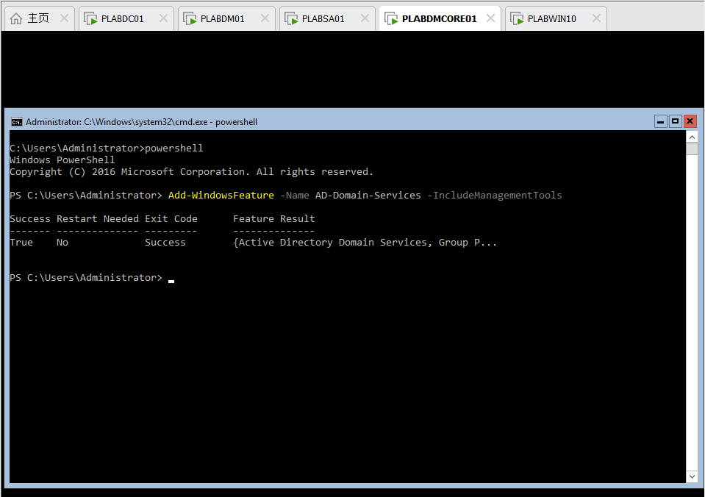

Figure 13 PLABDMCORE01: ADDS Installation is done

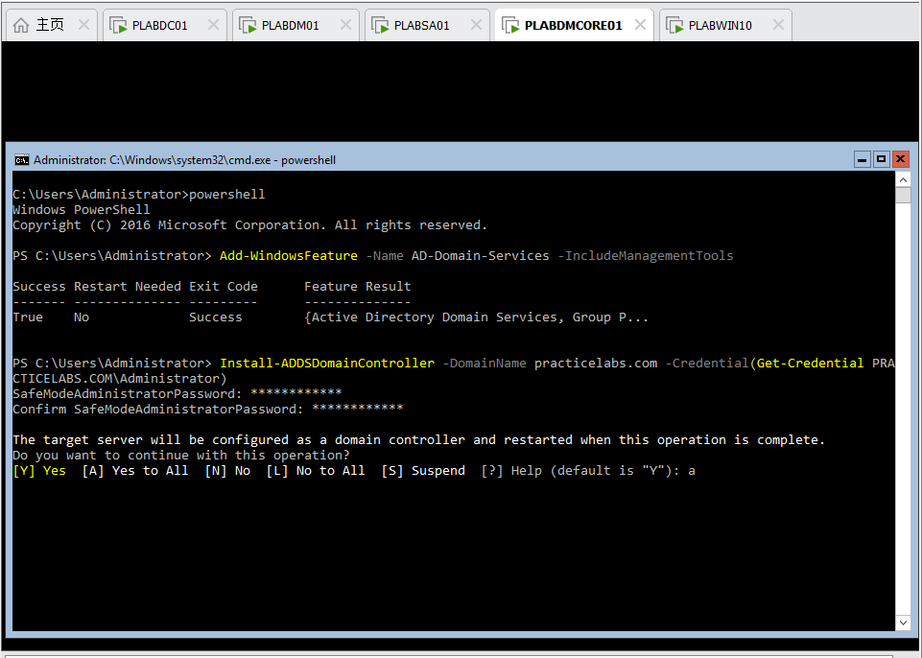

Figure 14 PLABDMCORE01: Configure ADDS SafeModeAdministratorPassword and restart, then plabdmcore01 setup is done

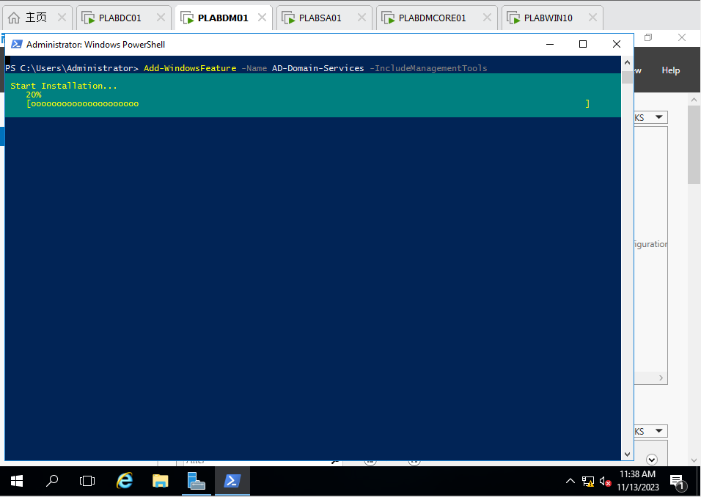

Figure 15 PLABDM01: Install ADDS including ManagementTools

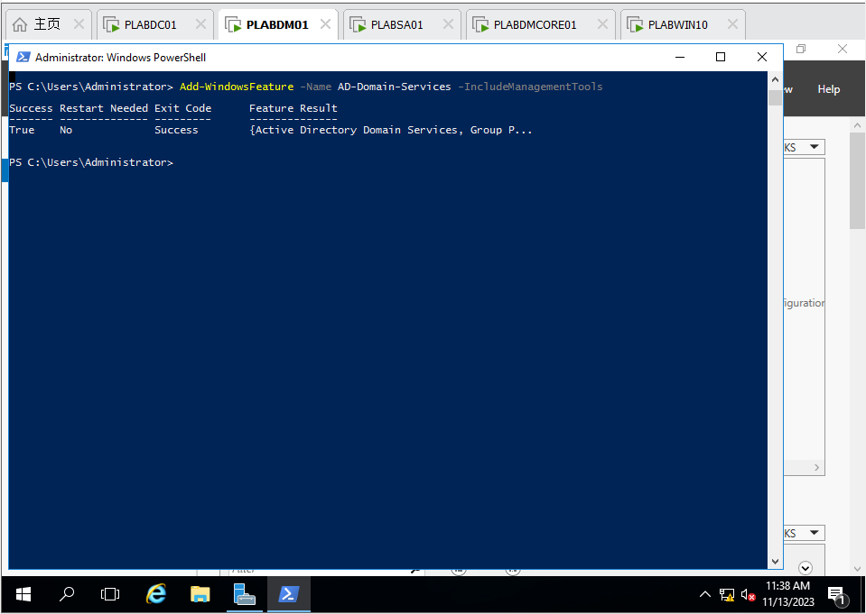

Figure 16 PLABDM01: The ADDS with ManagementTools is done

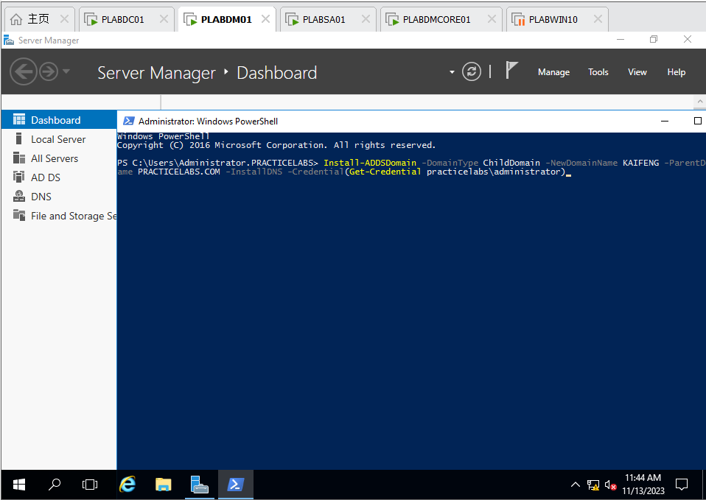

Figure 17 PLABDM01: Set plabdm01 as child domain (KAIFENG) of practicelabs.com

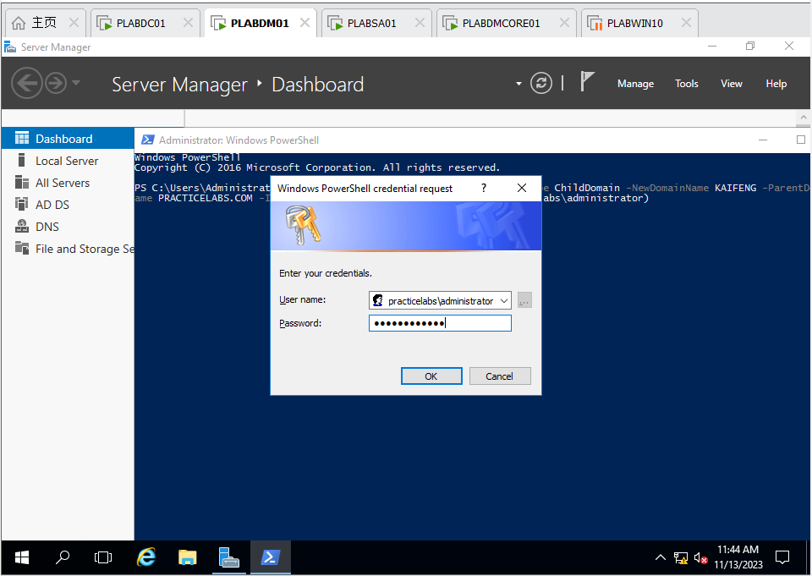

Figure 18 PLABDM01: Enter the password of *practicelabs.com*

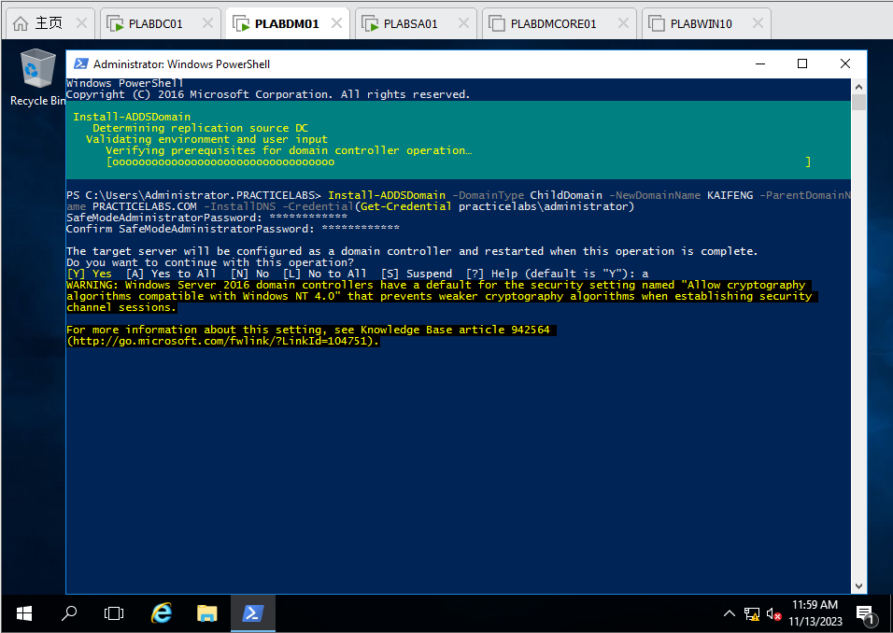

Figure 19 PLABDM01: Installing child domain (*KAIFENG*)

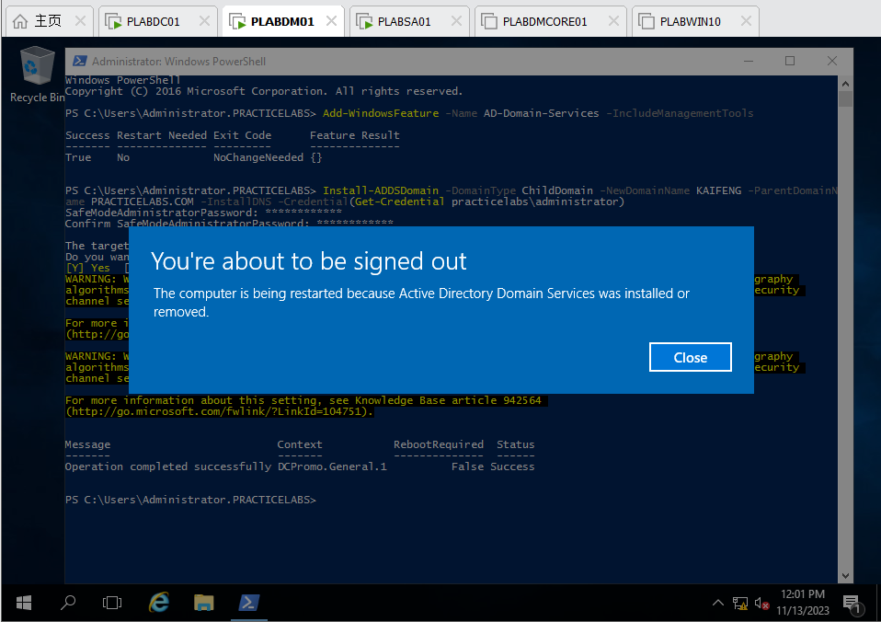

Figure 20 PLABDM01: Install successfully and reboot

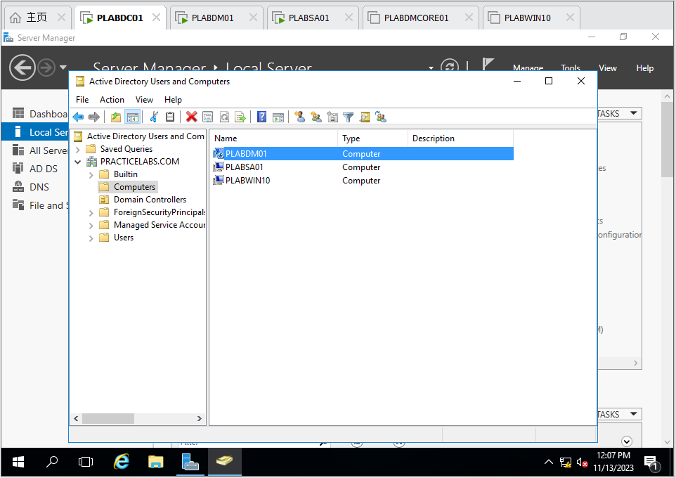

Figure 21 PLABDC01: Check the *plabdm01* and the child domain *KAIFENG* is installed successfully

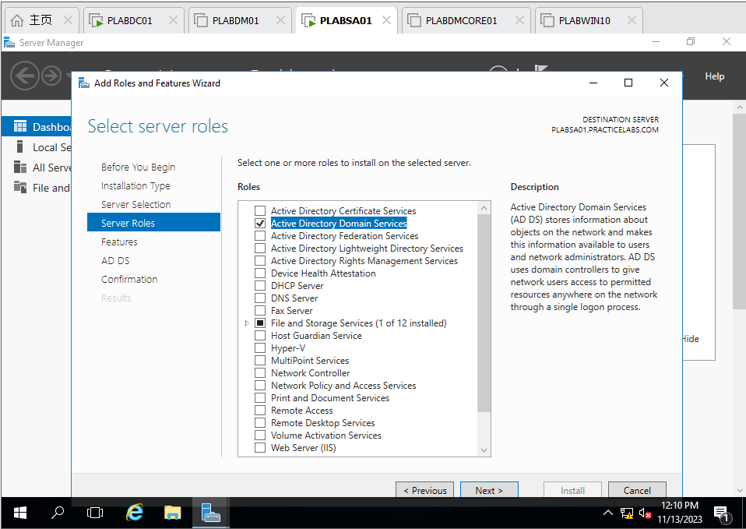

Figure 22 PLABSA01: Choose ADDS Service installation in Add Roles and Features Wizard

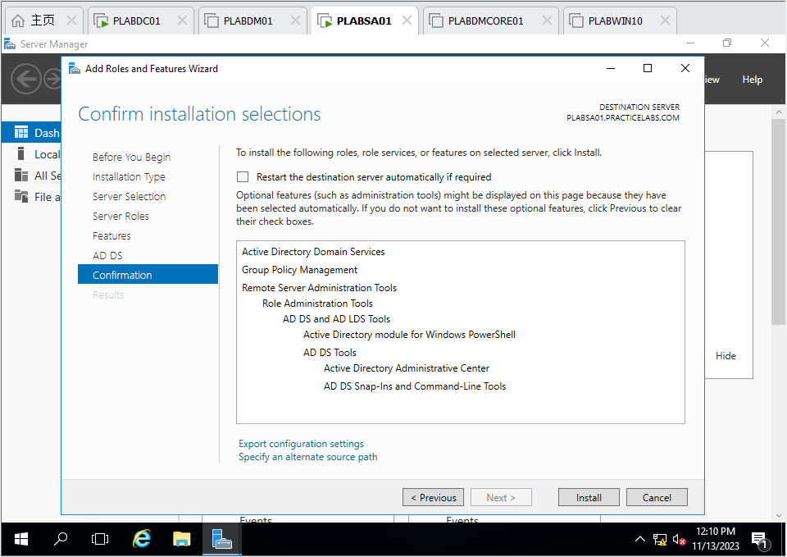

Figure 23 PLABSA01: The confirmation of ADDS Service

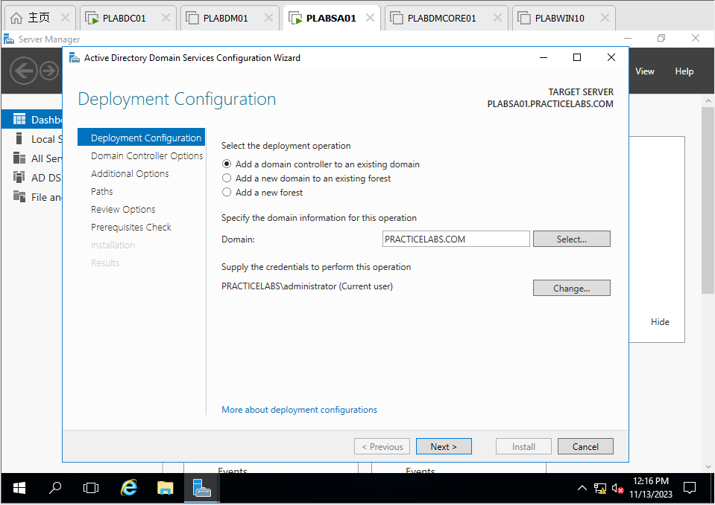

Figure 24 PLABSA01: After installing ADDS, set it as a domain controller of *practicelabs.com*

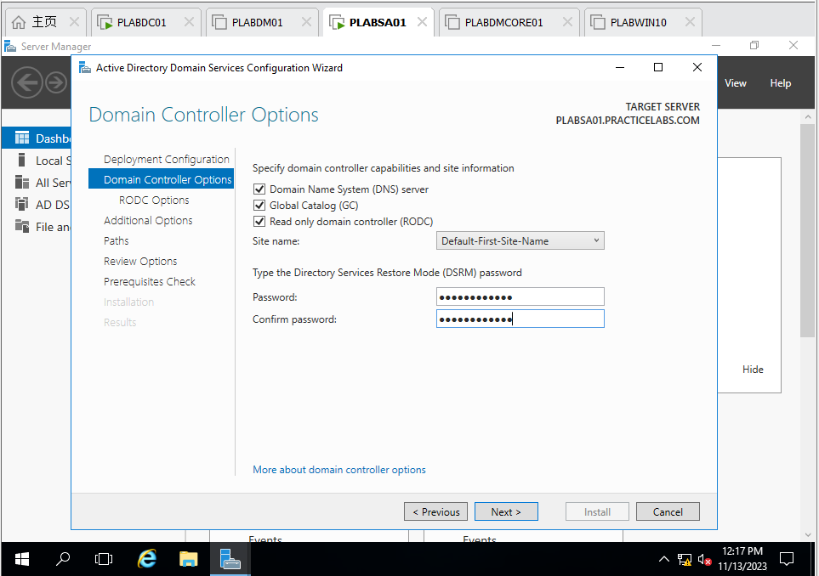

Figure 25 PLABSA01: Set is as Read only domain controller of practicelabs.com

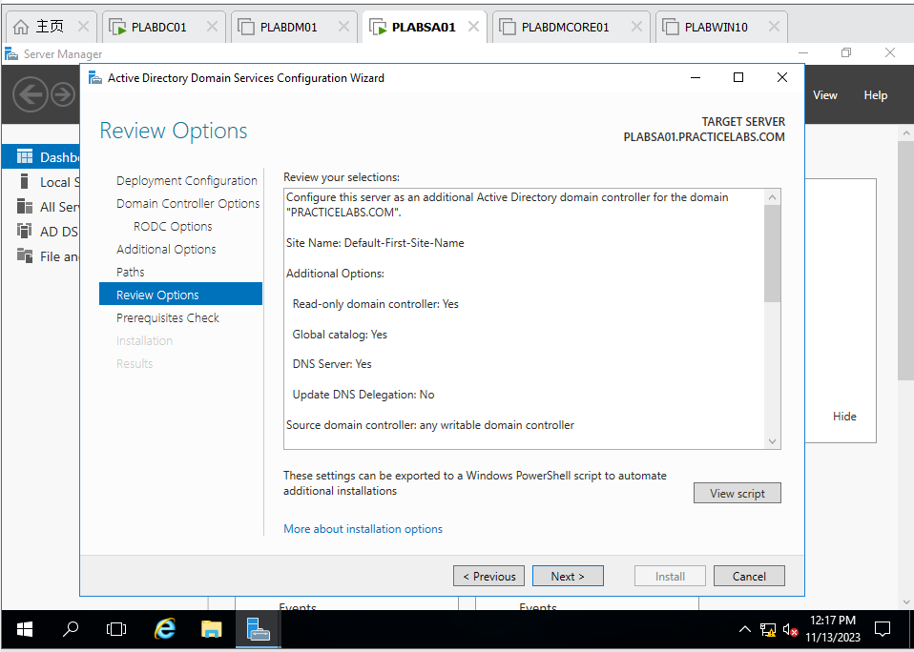

Figure 26 PLABSA01: Review options of ADDS Configuration Wizard

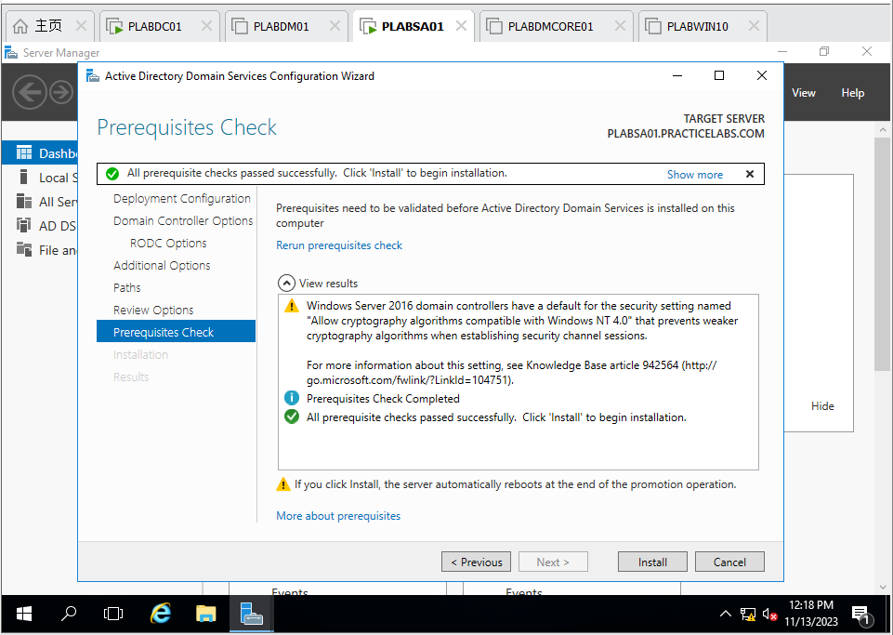

Figure 27 PLABSA01: Prerequisites check of ADDS Configuration Wizard

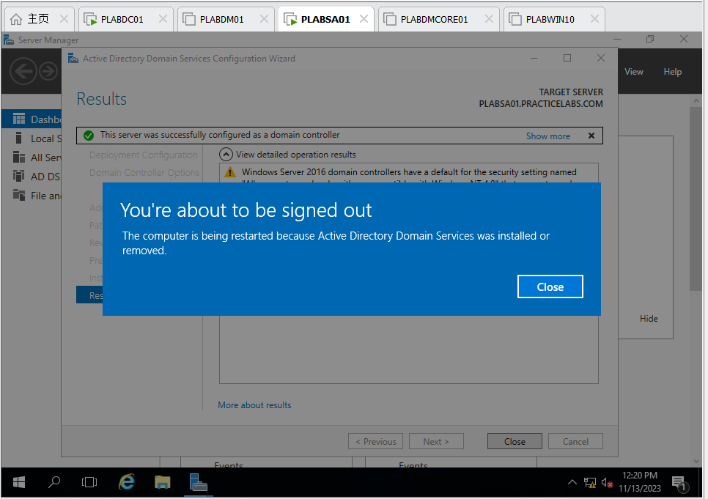

Figure 28 PLABSA01: After installation, reboot plabsa01

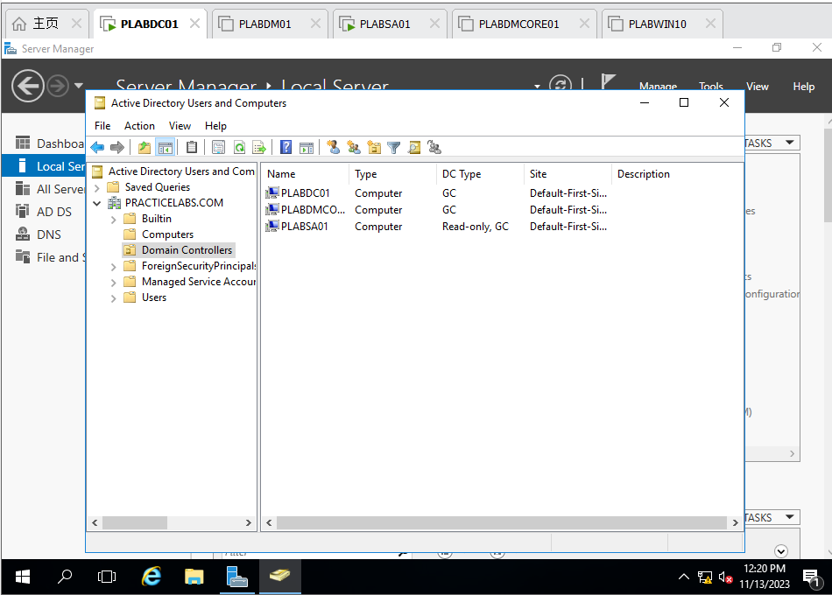

Figure 29 PLABDC01: Check the *plabsa01* installation and it is done

Use commands **dates;ipconfig /all** to verify the new configurations, and take screenshots for each server/computer.

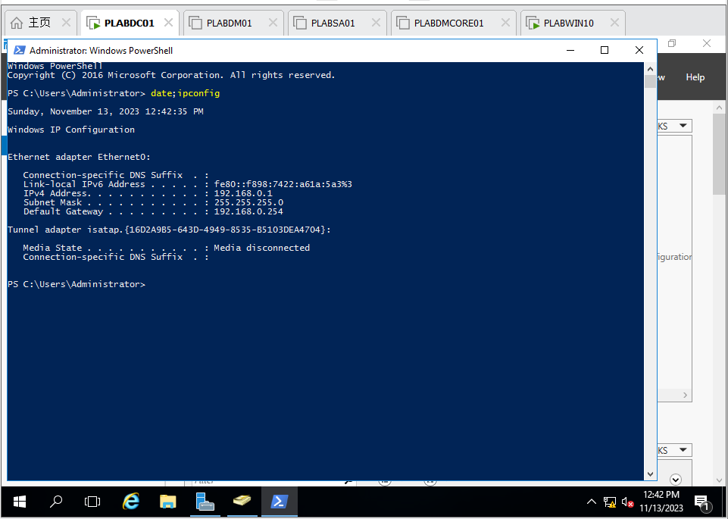

Figure 30 PLABDC01: command date;ipconfig

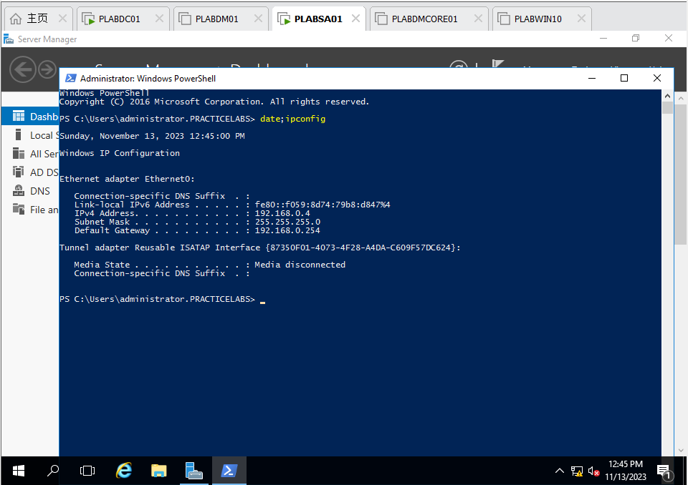

Figure 31 PLABSA01: command date;ipconfig

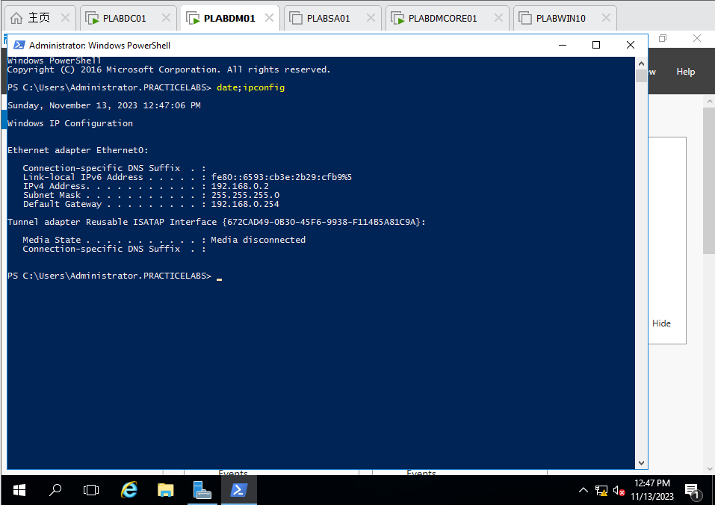

Figure 32 PLABDM01: command date;ipconfig

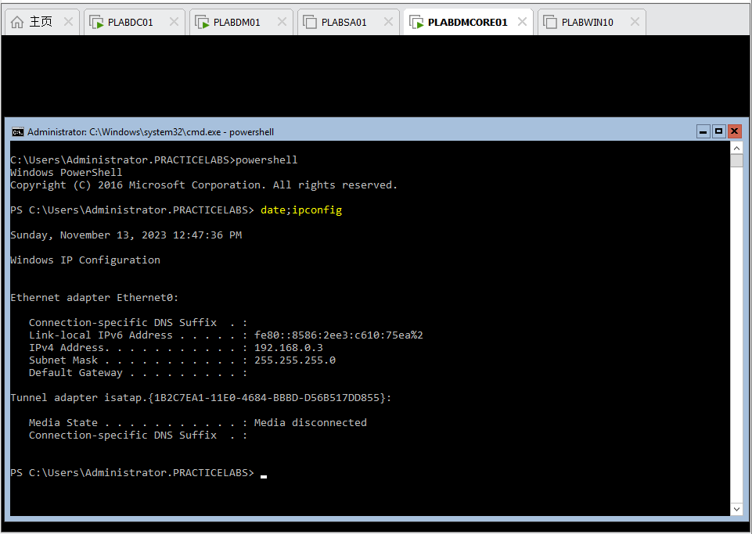

Figure 33 PLABDMCORE01: command date;ipconfig

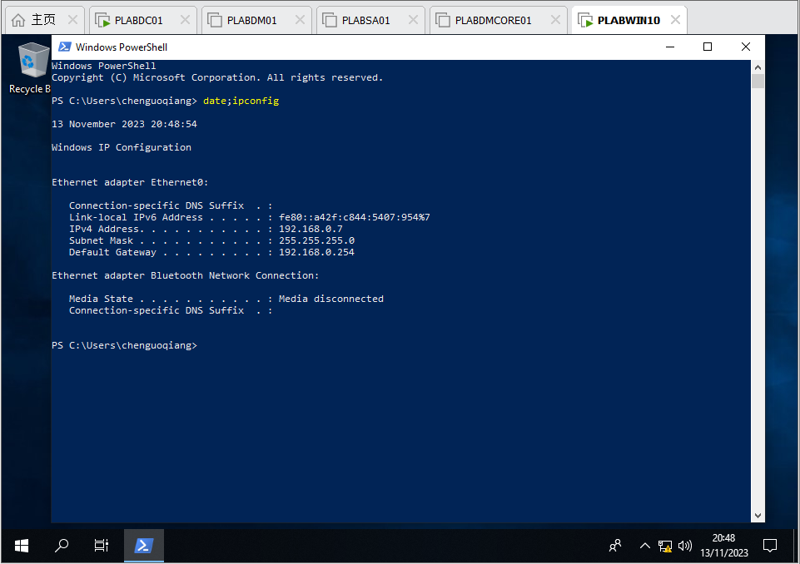

Figure 34 PLABWIN10: command date;ipconfi

**Task 3 – Active Directory Management** (15%)

• **A – User Account and Group Management** (5%)

o Create an Organization Unit called **NIT3122HENU**

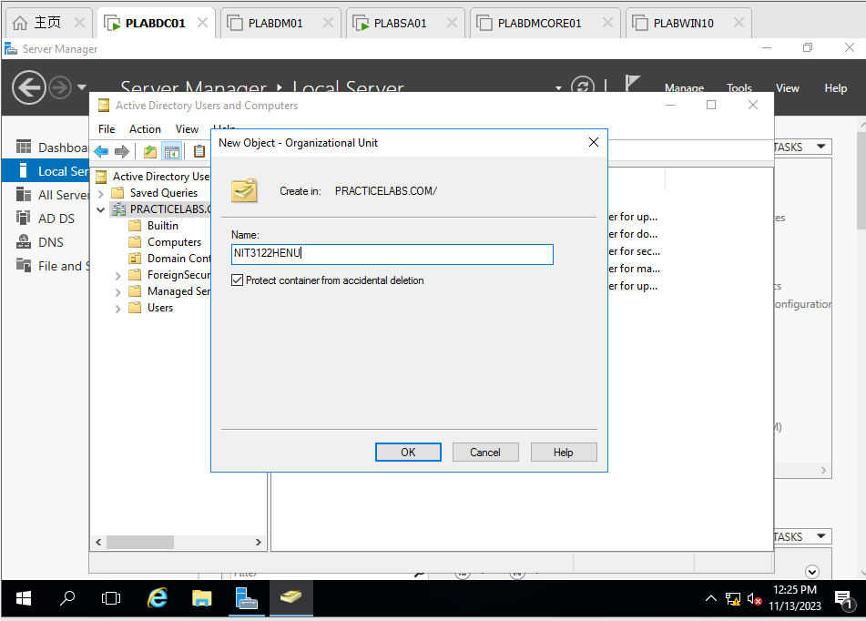

Figure 35 PLABDC01: Create NIT3122HENU OU in practicelabs.com

Inside **NIT3122HENU** OU, create a global security group called **NIT3122CGO**.

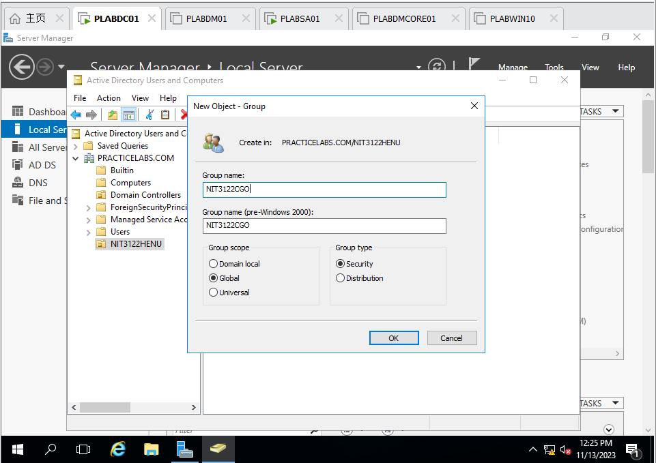

Figure 36 PLABDC01: Create NIT3122CGO IN NIT3122HENU

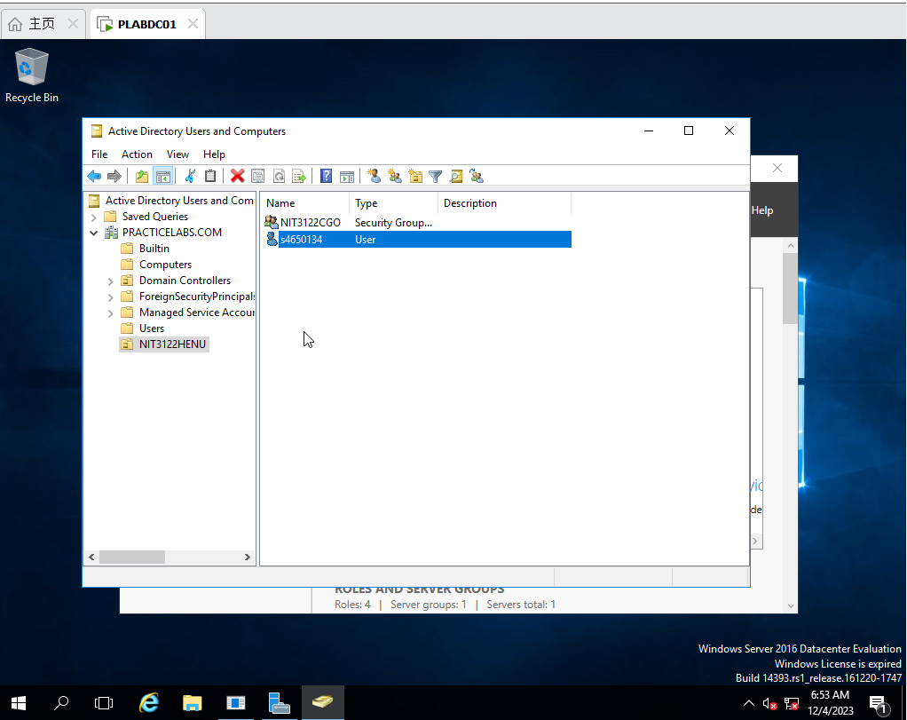

Figure 37 PLABDC01: Check NIT3122CGO successfully

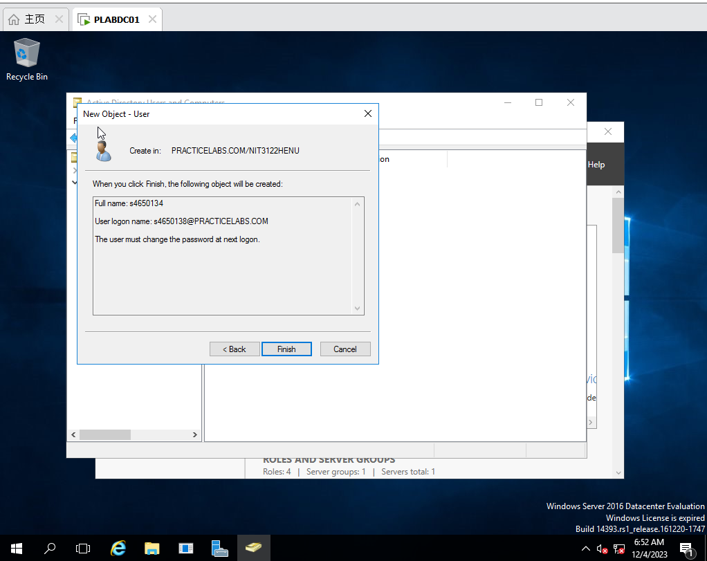

Figure 38 PLABDC01: Create new user s4650134 and enable User must change password at next logon

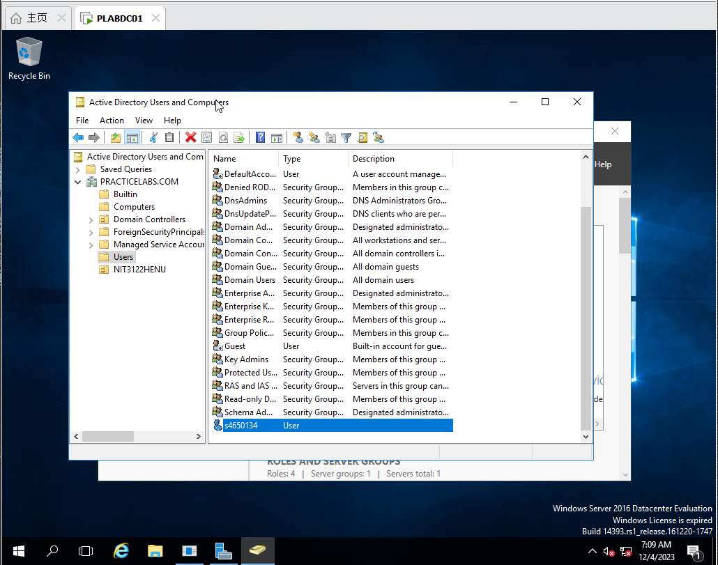

Figure 39 PLABDC01: create new user s4650134 successfully

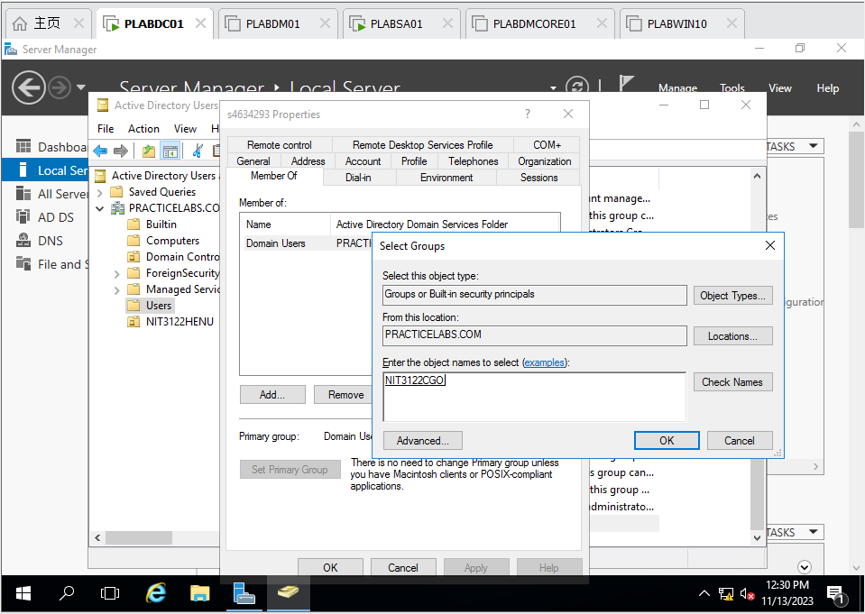

Figure 40 PLABDC01 : make s4650134 belongs to NIT3122CGO

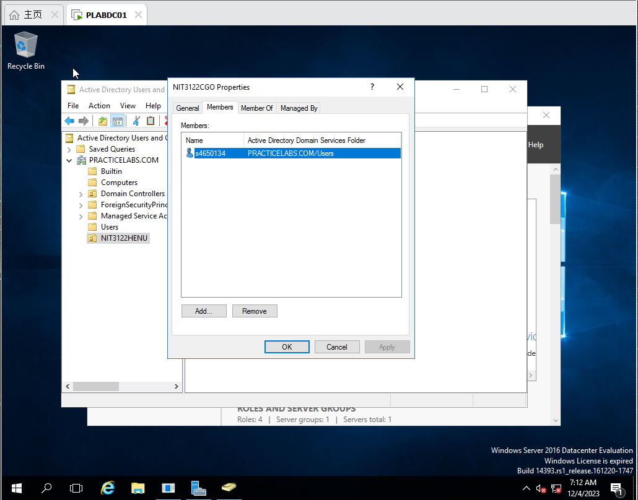

Figure 41 PLABDC01: join successfully

o Create 2nd new user using your **Lab Tutor’s** name as Domain **Administrator** who is a member of **NIT3122CGO** and whose password never expiries.

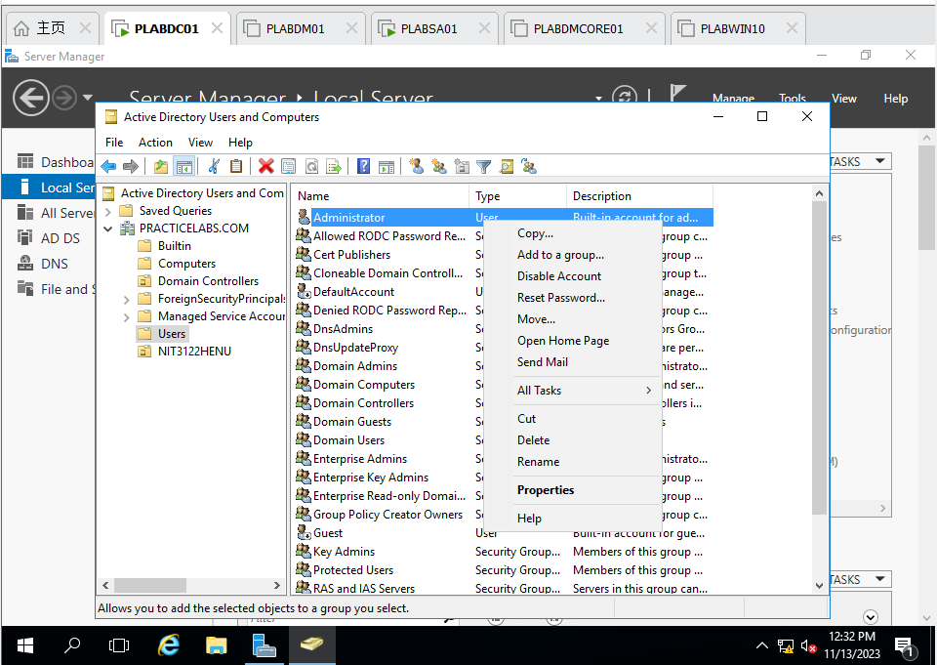

Figure 42 PLABDC01: Copy Administrator as new user Chen Guoqiang

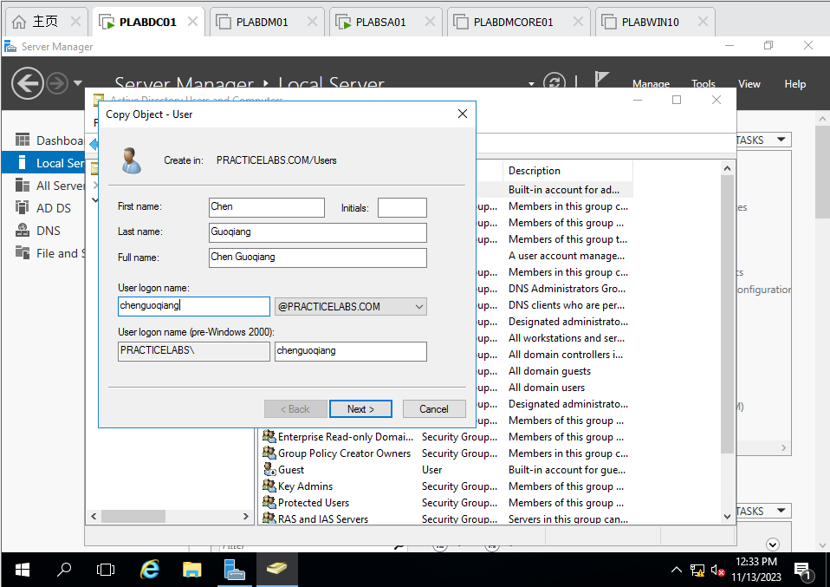

Figure 43 PLABDC01: setup information of user Chen Guoqiang

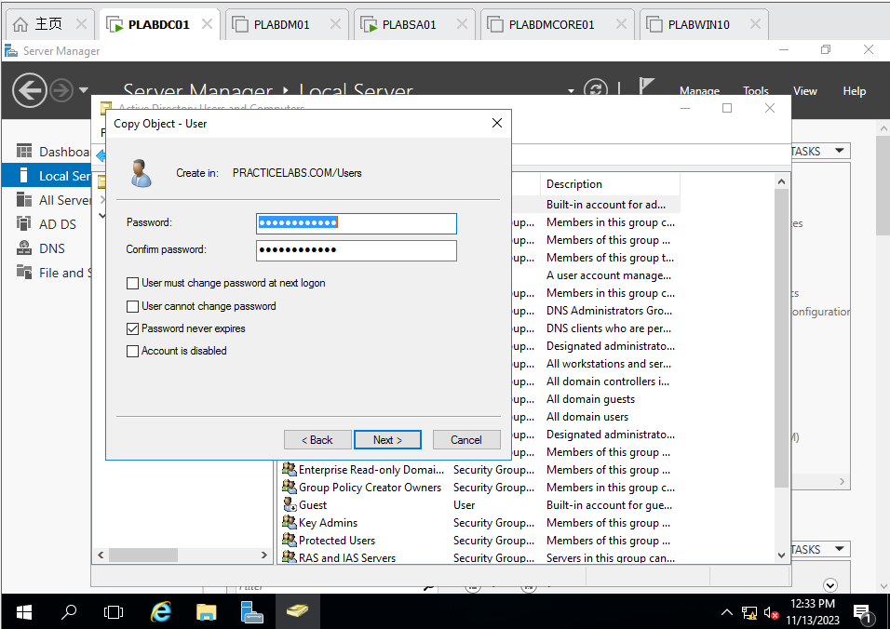

Figure 44 PLABDC01: Setup password of user Chen Guoqiang (CHECK Password never expires)

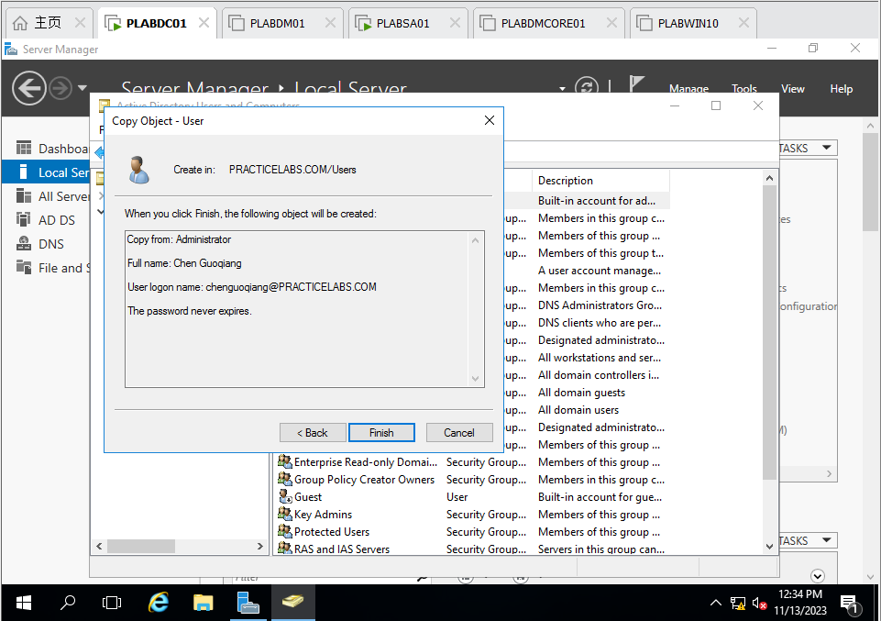

Figure 45 PLABDC01: Overview of User Chen Guoqiang

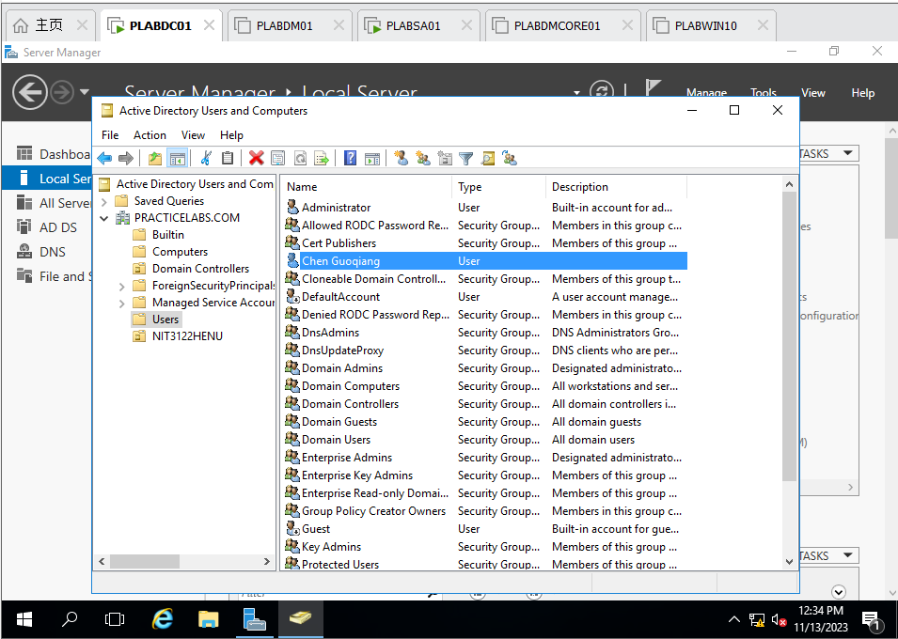

Figure 46 PLABDC01: Check User Chen Guoqiang created successfully

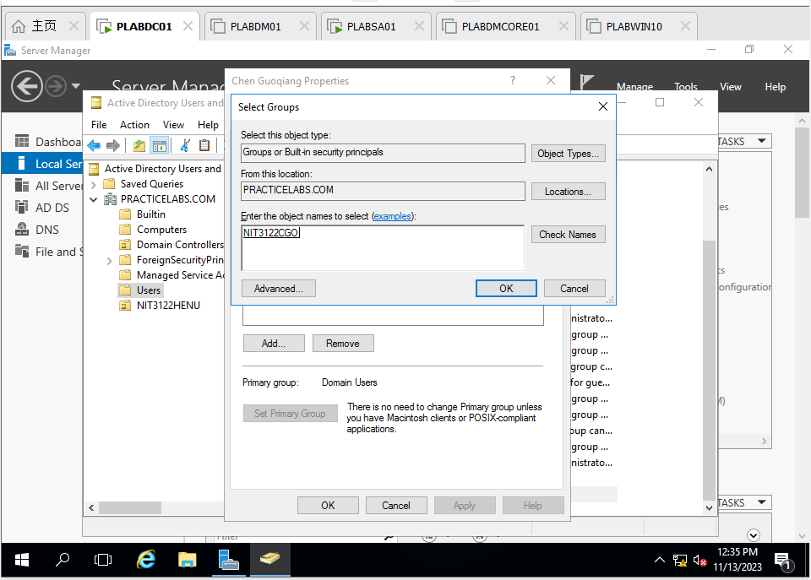

Figure 47 PLABDC01: Add User Chen Guoqiang to NIT3122CGO

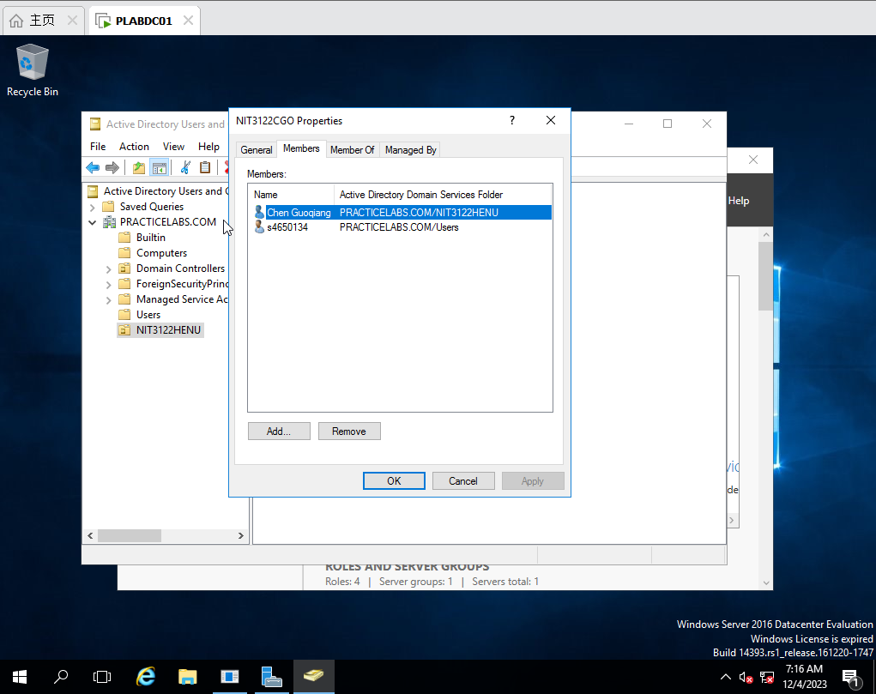

Figure 48 PLABDC01: Check Add successfully

o Log on the testing computer to verify the above two user settings are working.

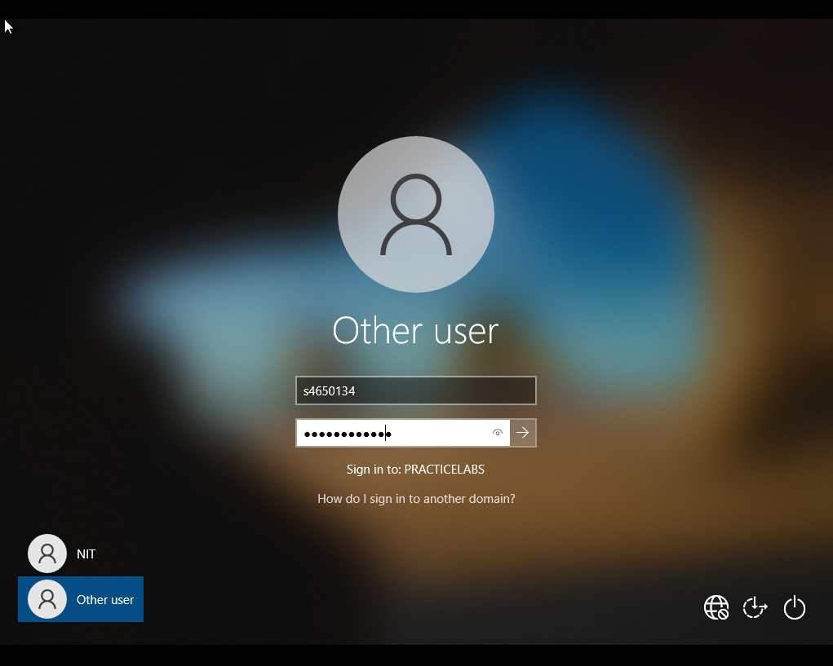

Figure 49 PLABWIN10: Log as s4650134

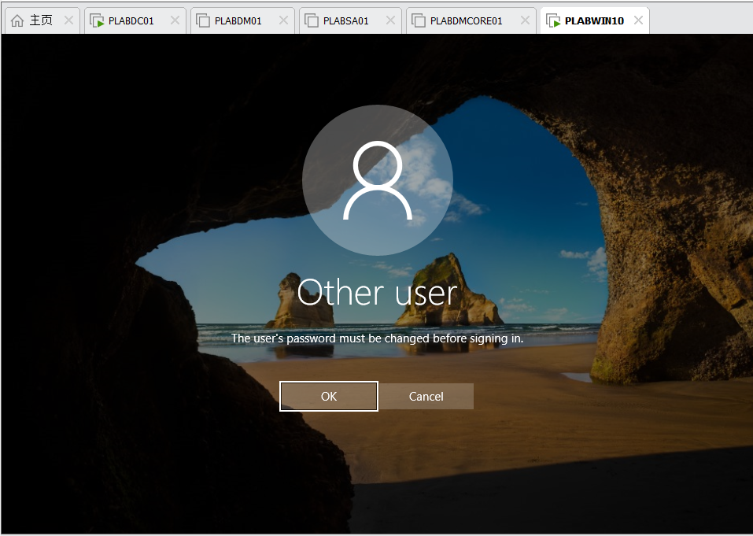

Figure 50 PLABWIN10: Notice that the password must be changed



Figure 51 PLABWIN10: enter new password

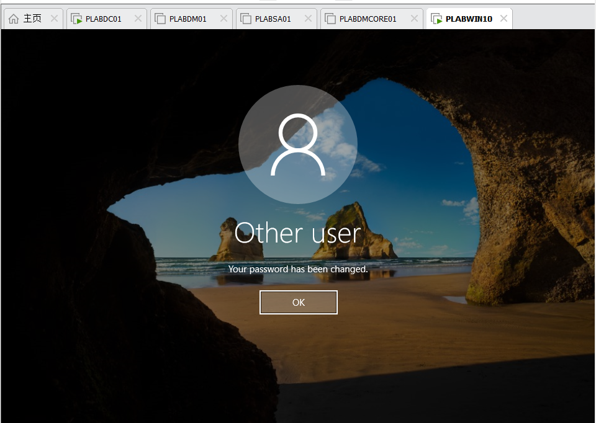

Figure 52 PLABWIN10: Change password successfully

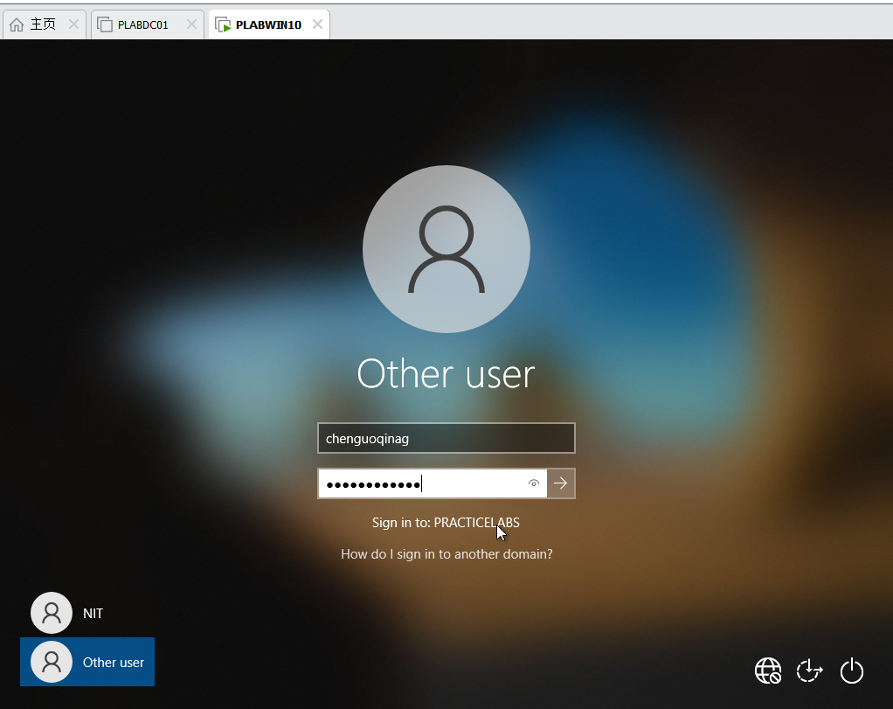

Figure 53 PLABWIN10: Log as Chen Guoqiang

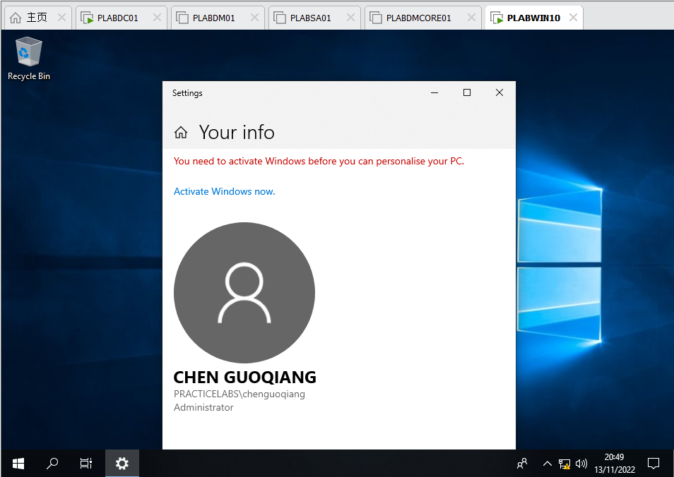

Figure 54 PLABWIN10: Check user information

o Take screenshots of the above account creation, **NIT3122HENU** folder and **NIT3122CGO** Member List.

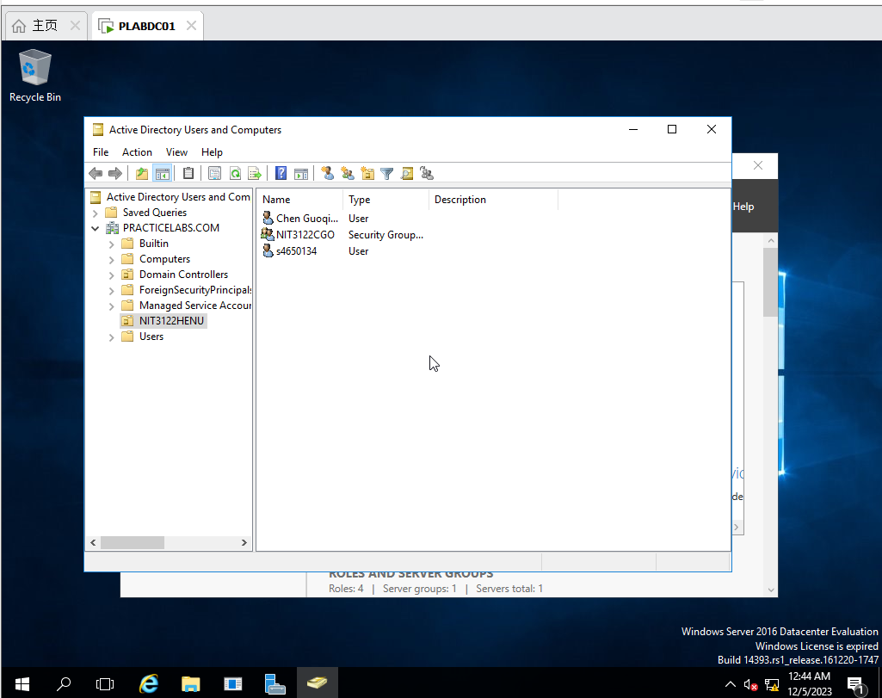

Figure 55 PLABDC01: Check items in NIT3122HENU



Figure 56 PLABDC01: Check members in NIT3122CGO

• **B – Application Management** (5%)

o Create a new GPO named “**Desktop restrictions**” which **Prohibit access to Control Panel and PC settings** for **NIT3122HENU** OU

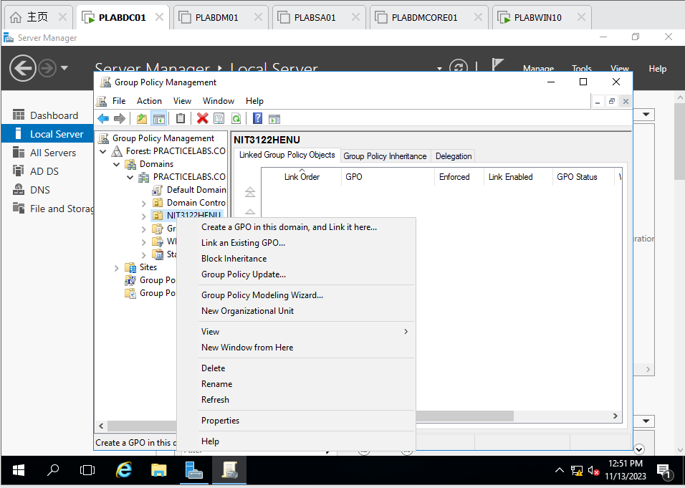

Figure 57 PLABDC01: Create a GPO for NIT3122HENU

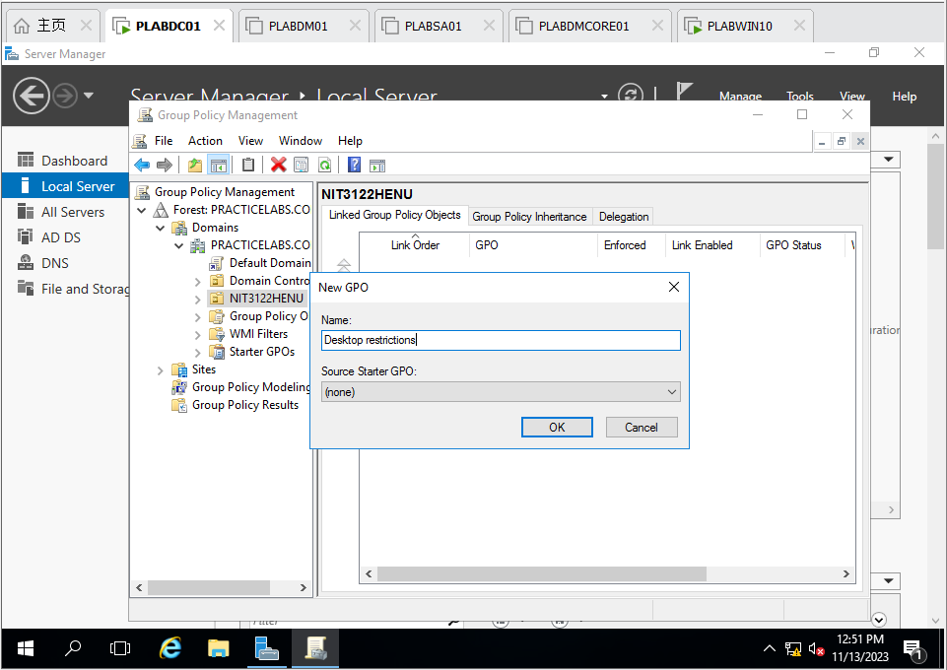

Figure 58 PLABDC01 : Name the GPO as Desktop restriction

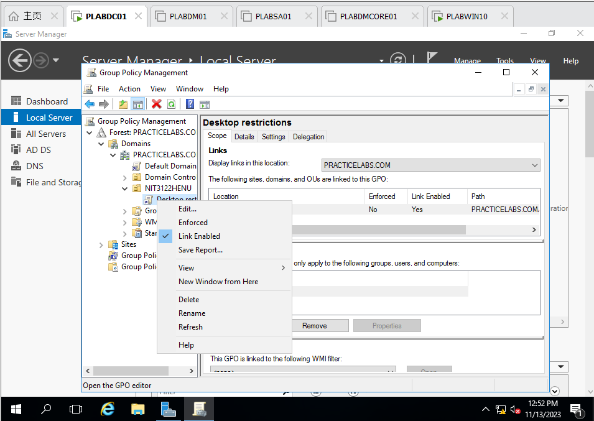

Figure 59 PLABDC01 : Edit the new policy

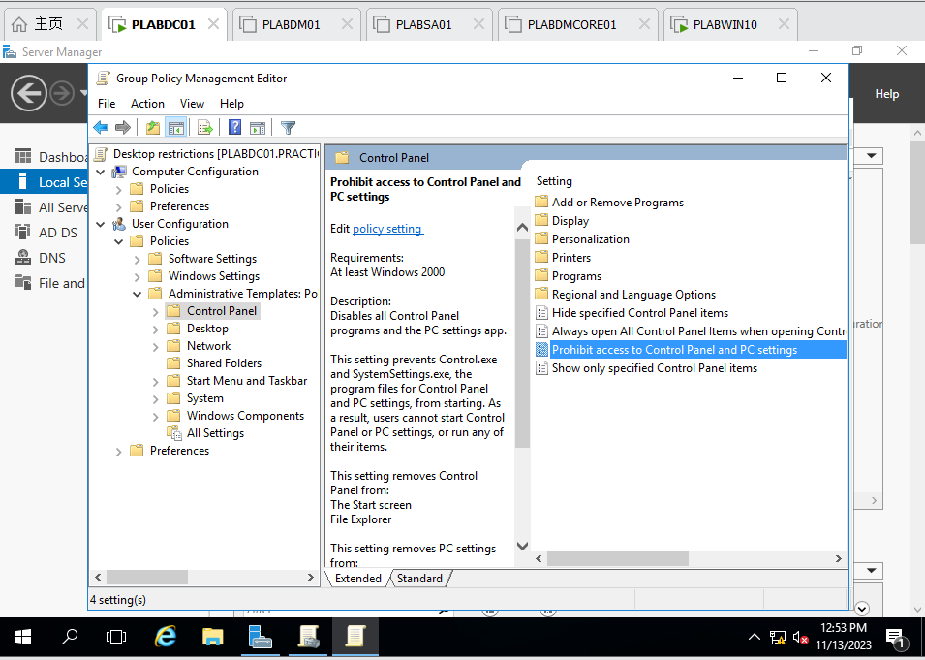

Figure 60 PLABDC01 : Select Prohibit access to Control Panel and PC settings and edit

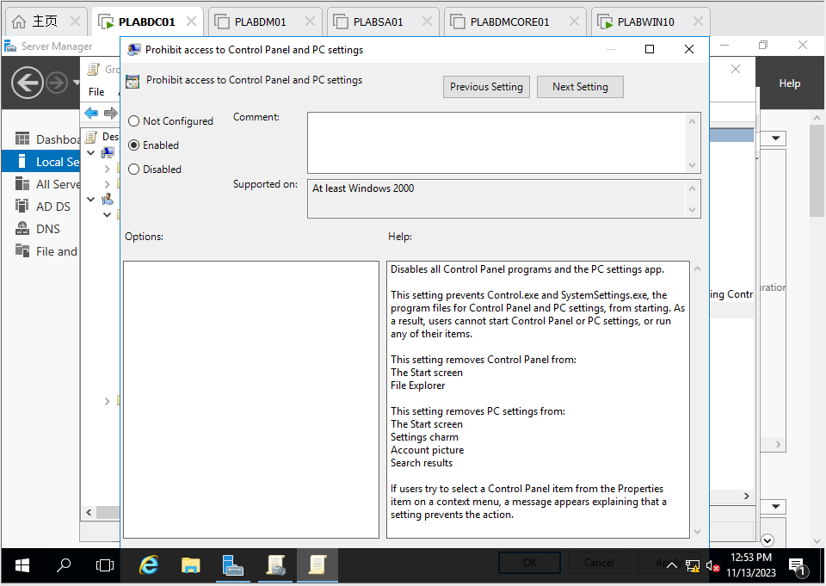

Figure 61 PLABDC01 : Choose Enable button

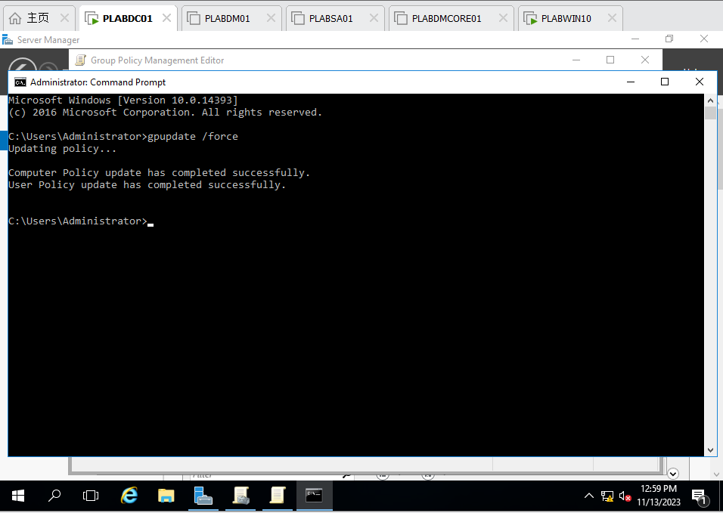

Figure 62 PLABDC01 : Update the policy and apply

o Use **YourID** to log on the testing computer to verify the setting is working.

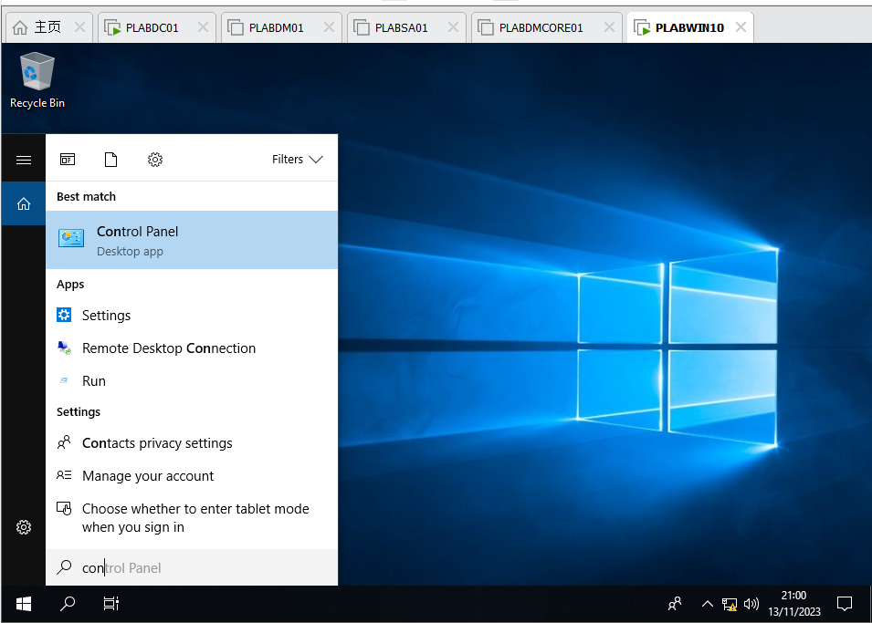

Figure 63 PLABWIN10 : Find Control Panel

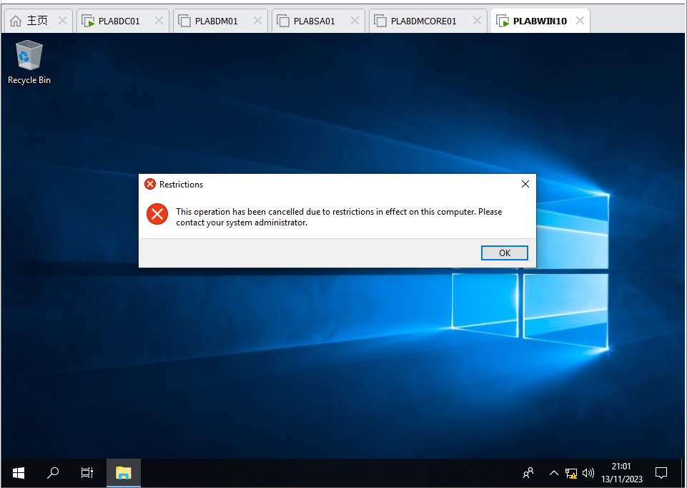

Figure 64 PLABWIN10 : Try to launch Control Panel and find it is not work because the Group Policy prohibit

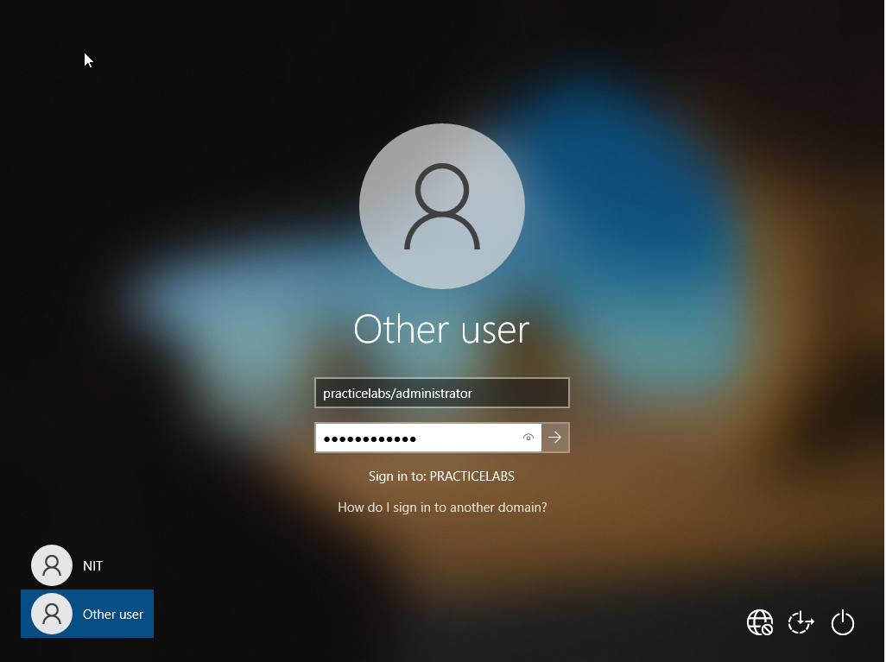

Figure 65 PLABWIN10: Enter password of administrator

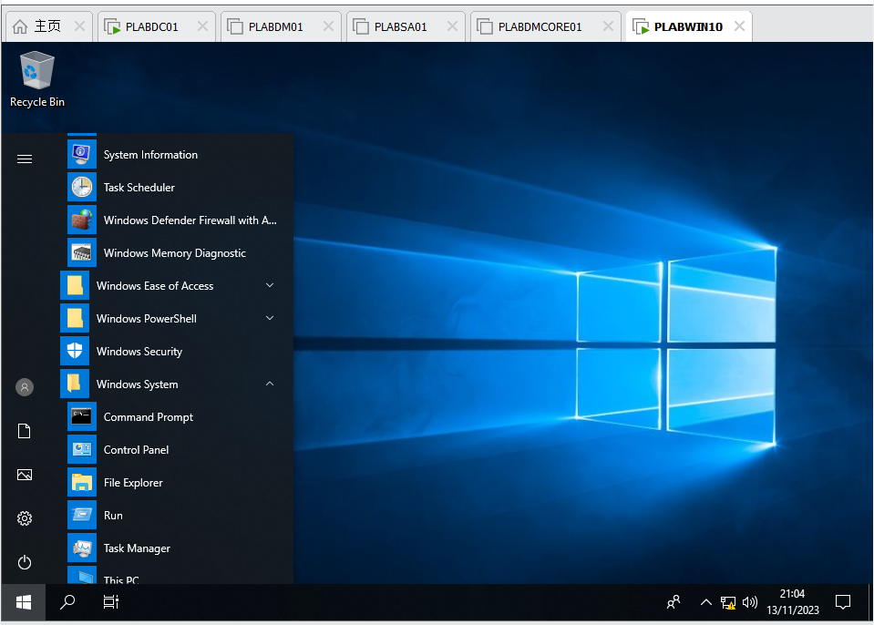

Figure 66 PLABWIN10 : Find Control Panel

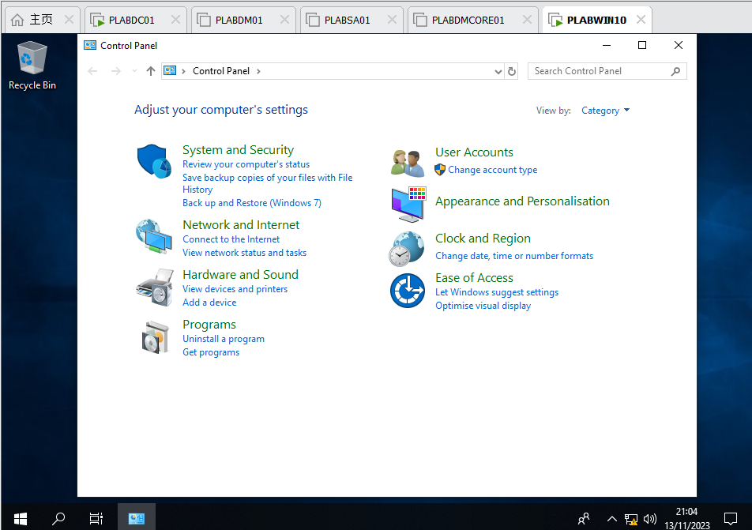

Figure 67 PLABWIN10 : launch Control Panel successfully

o Take screenshots of the above procedures and explain the results.

• **C –** **Software Management** (5%)

o Create another new GPO named “**Software restrictions**” which block users in **NIT3122CGO** from opening **Notepad.exe** on any computer in the domain **PracticeLabs.com**.

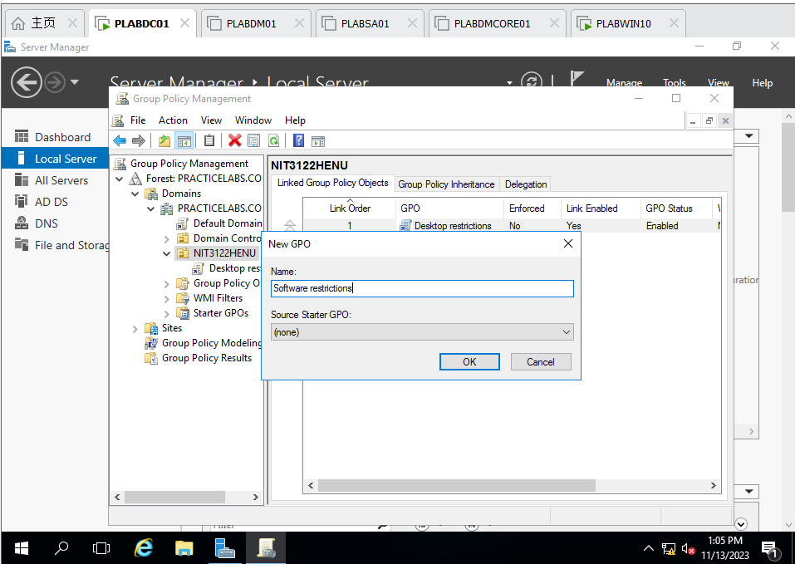

Figure 68 PLABDC01 : Back to Plabdc01 and create new GPO named Software restrictions

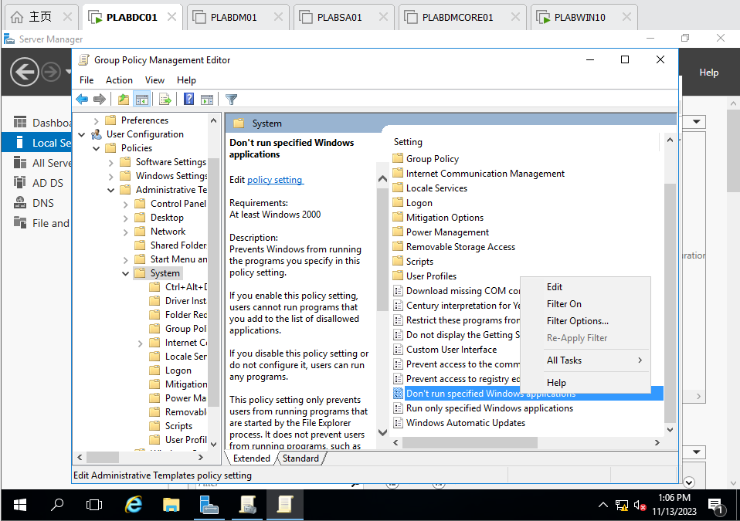

Figure 69 PLABDC01 : Find Don’t run specified Windows applications and edit

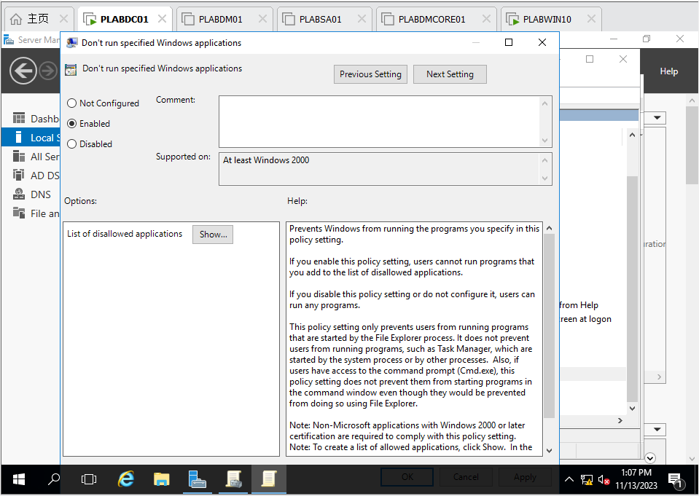

Figure 70 PLABDC01 : Choose Enable and click show

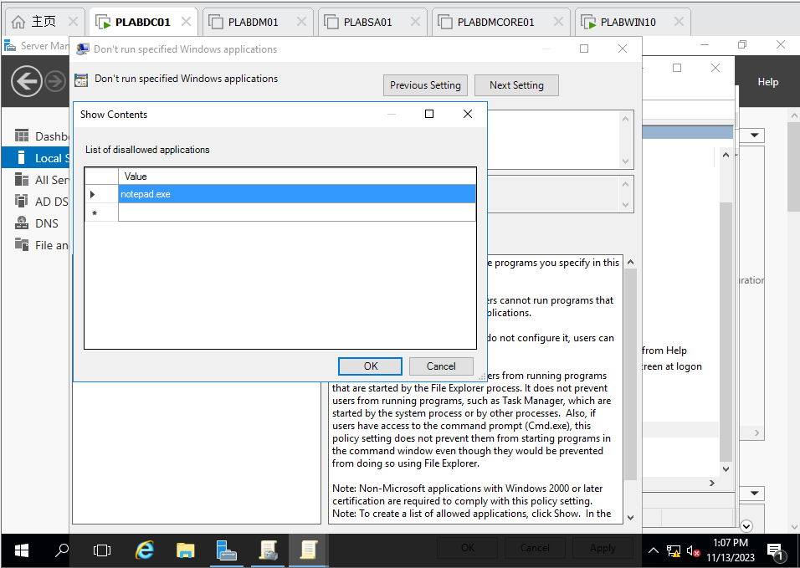

Figure 71 PLABDC01 : Enter notepad.exe, prohibit this application

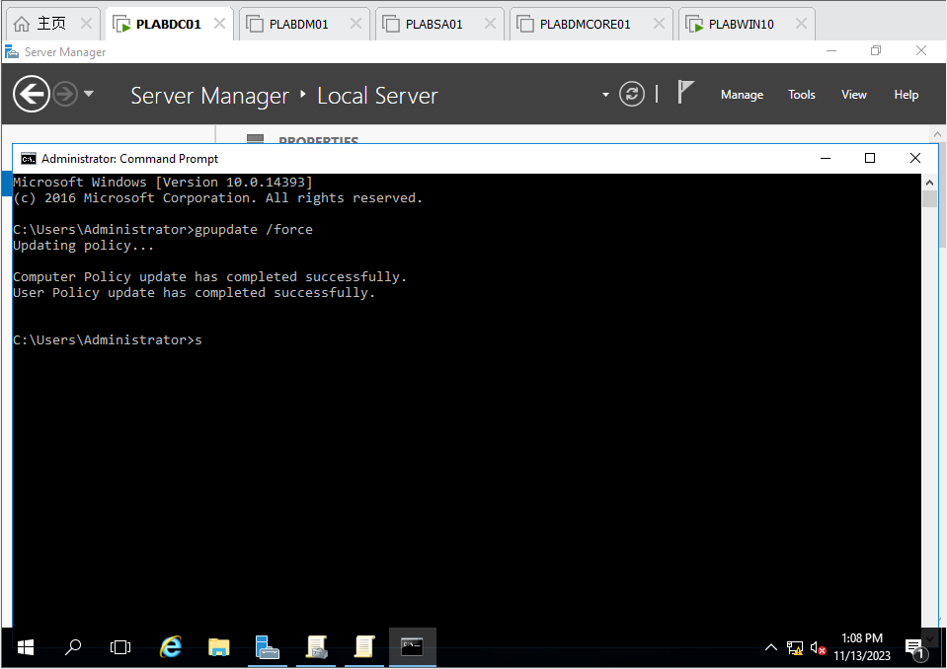

Figure 72 PLABDC01 : Update the policy successfully

o Use **YourID** to log on the testing computer (**PLABWIN10**) to verify if Notepad.exe can be opened.



Figure 73 PLABWIN10 : Login as s4650134

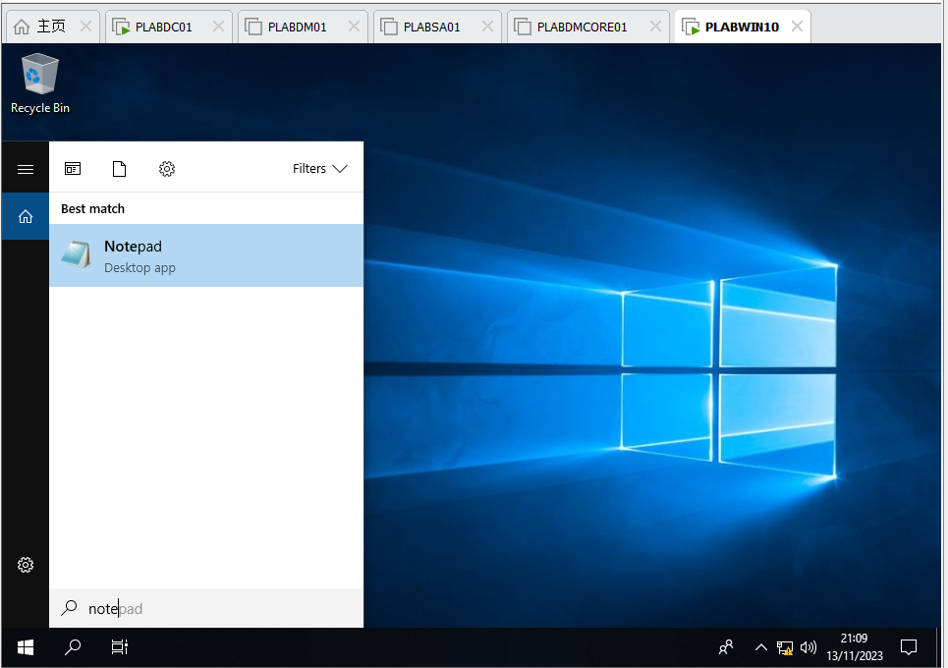

Figure 74 PLABWIN10 : Find Notepad application and try to launch, find that it is prohibited because the policy worked

o Use **Lisa.Scott,** an existing user to log on the testing computer (**PLABWIN10**) to verify the setting.

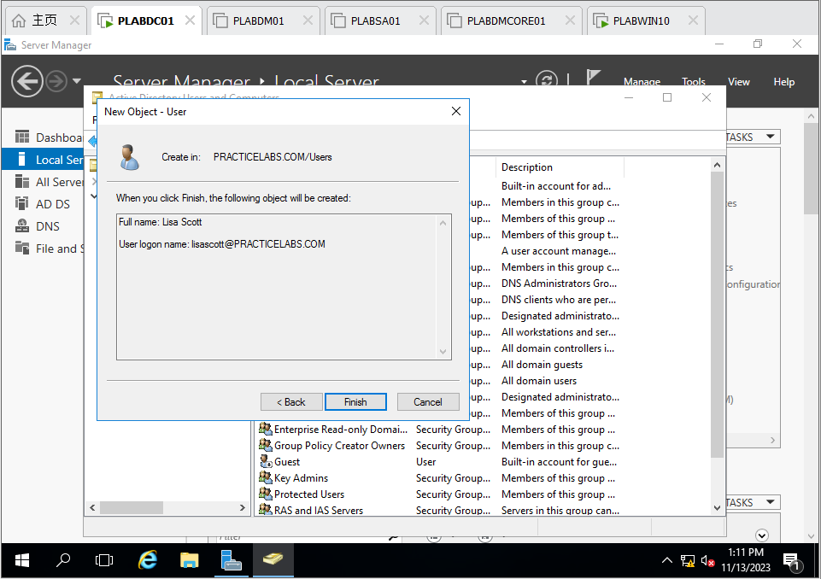

Figure 75 PLABDC01 : Create new user lisascott

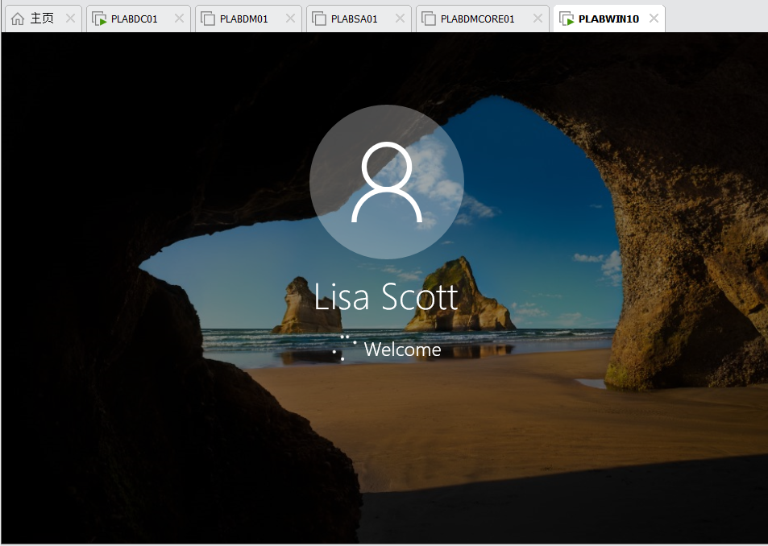

Figure 76 PLABWIN10 : Login as Lisa Scott

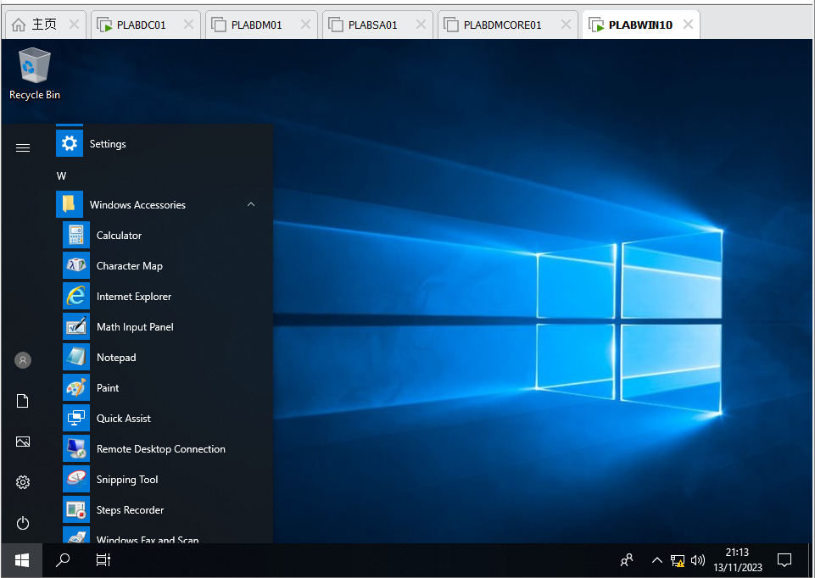

Figure 77 PLABWIN10 : Find the Notepad and try to launch it

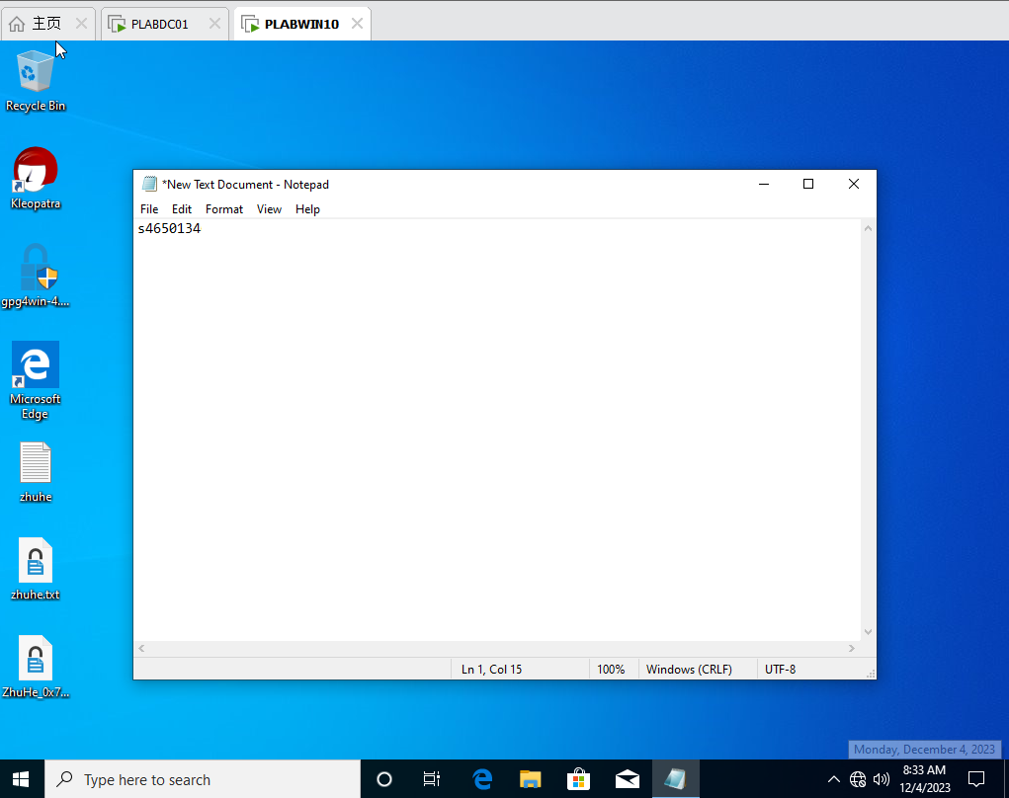

Figure78 PLABWIN10 : launch notepad.exe successfully

o Set **Lisa.Scott** as a member of **NIT3122CGO** and, then logon to verify the setting.

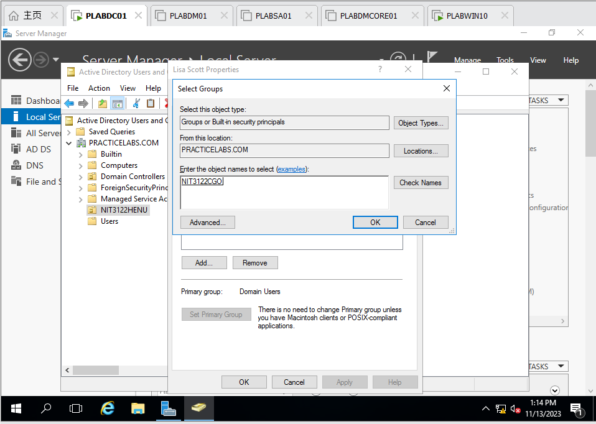

Figure 79 PLABDC01 : Add Lisa Scott to NIT3122CGO

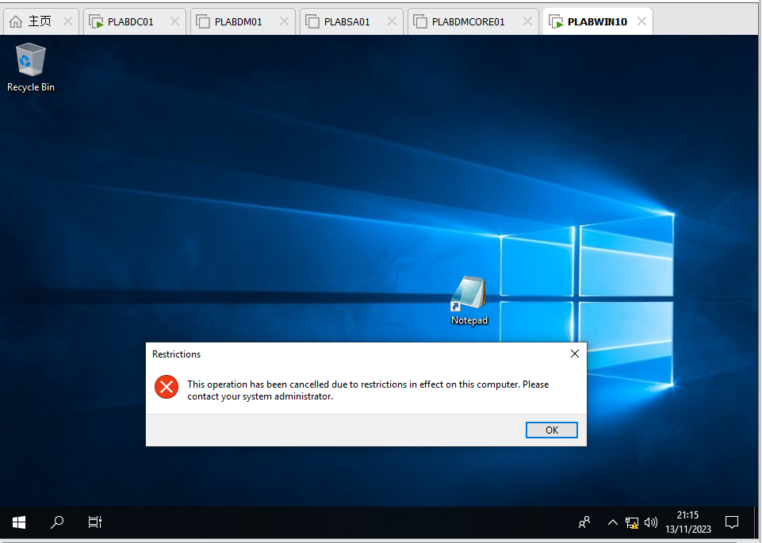

Figure 80 PLABWIN10 : Try to launch notepad and find it is prohibited because the Group policy prohibited

o Take screenshots of the above procedures and explain the results.

 Use commands **dates;ipconfig /all** to record the configurations, and take screenshots for each server/computer.

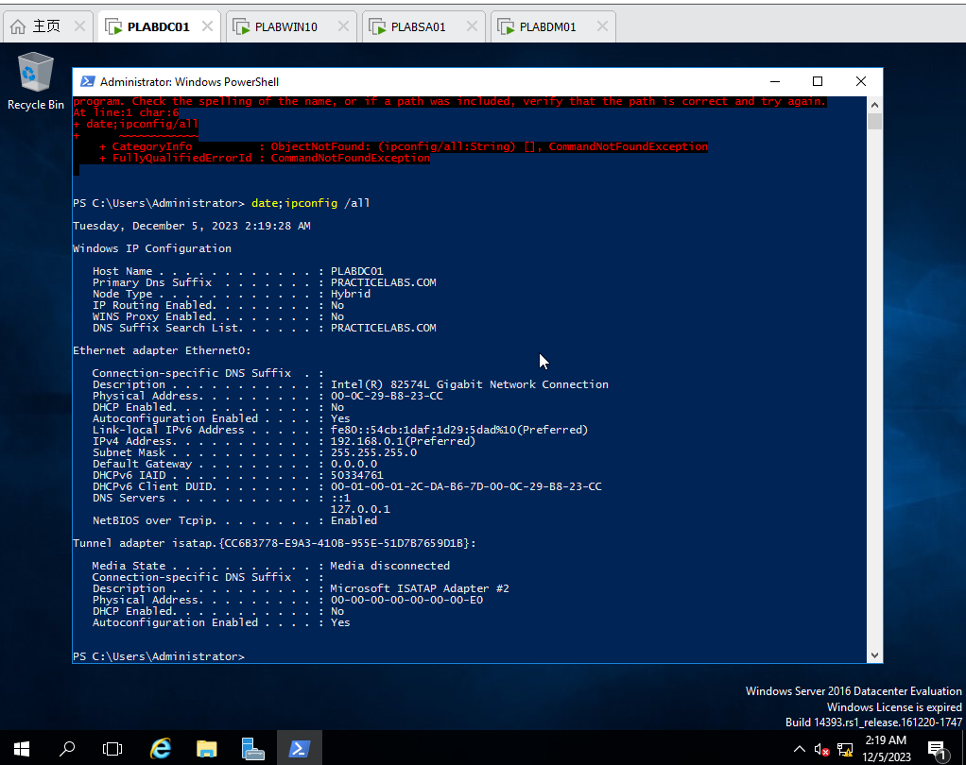

Figure 81 PLABDC01 : date;ipconfig /all

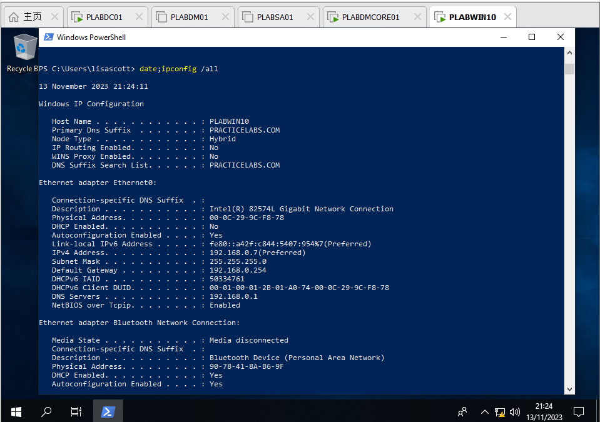

Figure 82 PLABWIN10 : date;ipconfig /all

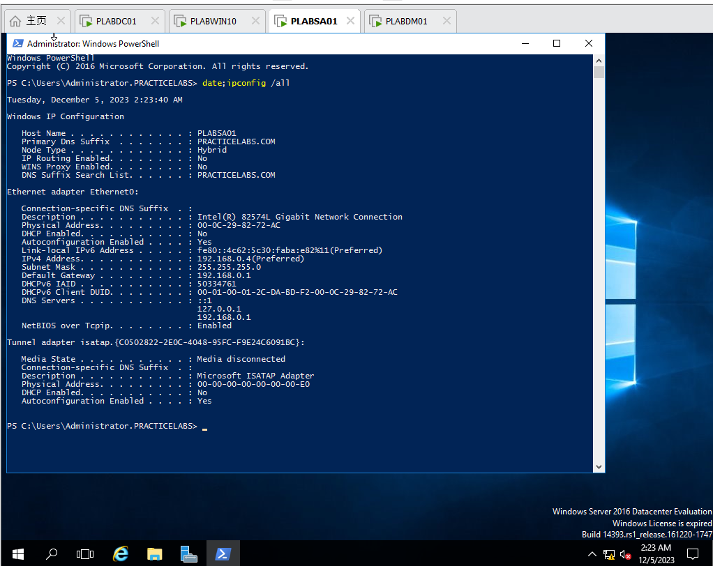

Figure 83 PLABSA01 : date;ipconfig /all

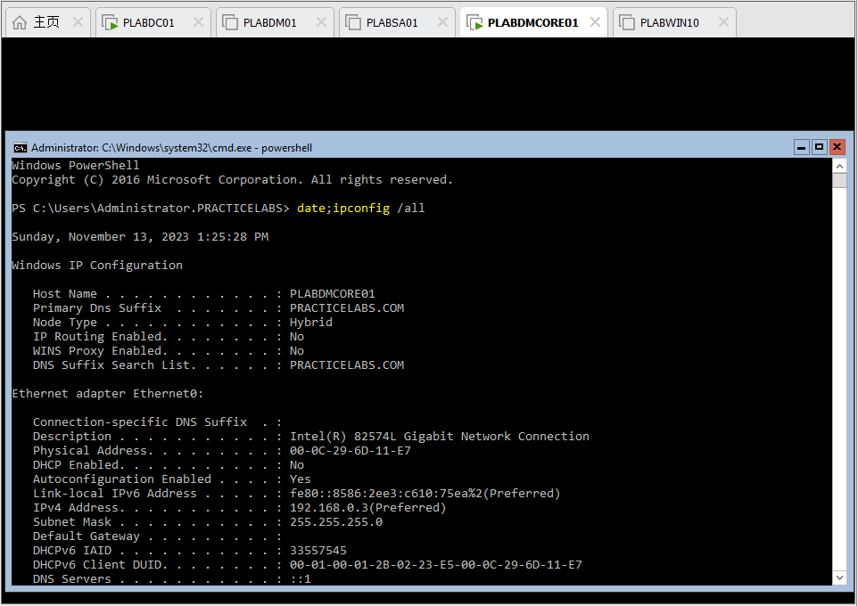

Figure 84 PLABDMCORE01 : date;ipconfig /all

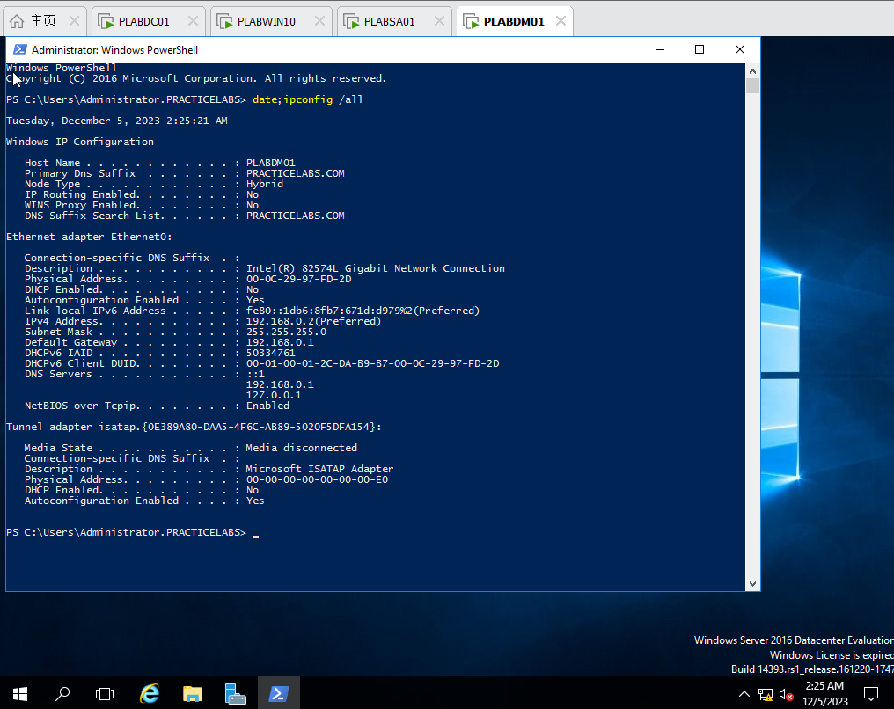

Figure 85 PLABDM01 : date;ipconfig /all

**Once you complete the Assignment**, log on VU Collaborate and upload your **Assignment_YourName_YourID.docx** via dropbox.